How to make dreamscape theme rooms more interactive. How to change dreamscapes from static environments to living experiences.

🌌 Sensory & Interactive Enhancements
- Touch-responsive surfaces: Panels or furniture that react to touch — glowing, changing color, or playing ambient sounds when touched.
- Motion-triggered lighting: LED systems that shimmer or pulse as someone walks by, simulating magic or energy flow.
- Projection mapping: Walls or ceilings that shift scenes — day/night cycles, moving clouds, underwater ripples — controlled by gesture or voice.
- Smart scent diffusers: Release thematic aromas (forest pine, ocean breeze, temple incense) synced with lighting or music.

🧠 Cognitive & Emotional Interaction
- AI-guided storytelling mode: The room narrates a story based on its theme — for example, the “Olympus Chamber” could tell myths while ambient light dramatizes key moments.
- Mood-adaptive lighting: Sensors detect tone or activity (reading, relaxing, playing) and adjust color temperature and brightness automatically.
- Dream journaling interface: A small console or app where users record dreams, which then influence the room’s visuals or music the next day.

🎮 Playful & Educational Features
- Augmented reality portals: Kids can scan symbols or carvings to unlock mini-games or mythic lore tied to the room’s theme.
- Modular puzzle furniture: Pieces that can be rearranged to reveal hidden compartments or interactive stories.
- Sound-reactive environments: Music or voice triggers visual effects — waves ripple, stars twinkle, or trees glow in rhythm.

🪄 Social & Creative Interaction
- Collaborative design mode: Families can co-create new themes through the AI portal — blending everyone’s ideas into one shared dream.
- Seasonal transformations: Rooms evolve automatically with holidays or personal milestones (birthday, anniversary, solstice).
- Live performance integration: For adults, the room could host immersive dinner parties or meditation sessions with synchronized light and sound choreography.

🕶️✨ DREAMSCAPE PROTOTYPE

“Austin Powers: The Mojo Lounge”
A modular, interactive, retro-spy Dreamscape room

1 — Core Theme Identity
This room is built around the visual language of:
- 1960s psychedelic pop art
- Velvet, shag, chrome, and curves
- Spy-lair gadgets and hidden compartments
- Groovy lighting and saturated color
- Playful, flirtatious energy
Emotionally, the room expresses the Muse, Lover, and Showman archetypes.

2 — Modular Furniture System (Dreamscape-Compatible)

🛏️ The “Mojo Bed” (Modular Bed System)
Core chassis:
- Rounded platform bed with hidden LED chamber
- Chrome perimeter frame
- Universal grid for interchangeable posts
Interchangeable posts:
- Lava lamp posts
- Chrome spiral posts
- Fuzzy heart-shaped posts
- “Shagadelic” acrylic swirl posts
Canopy module:
- Optional rotating disco-ball canopy
- Optional velvet drape canopy with fringe
Lighting behavior:
- Touch-reactive color shifts
- “Mojo Pulse Mode” (lights pulse to music)
- “Spy Mode” (lights dim and reveal hidden UV patterns)

🪞 The “Shagadelic Dresser” (Modular Dresser System)
Core chassis:
- Curved front
- Chrome handles
- LED underglow
Interchangeable sculptural panels:
- Psychedelic swirl panel
- Union Jack pop-art panel
- Velvet tufted panel
- Mirror-finish panel
Interactive features:
- Hidden compartment activated by voice (“Yeah baby!”)
- LED glow that reacts to movement

🚪 The “Secret Agent Wardrobe” (Modular Wardrobe System)
Slide-on skins:
- Velvet red
- Chrome + neon
- Pop-art comic panel
- 1960s mod pattern
Spy-lair features:
- Rotating wardrobe door (Bond-style)
- Hidden “gadget shelf”
- Built-in scent diffuser (vanilla, patchouli, or “Mojo Mist”)

3 — Theme Cartridge System (Environmental Transformation)

🌈 Floor Theme Trays
- Psychedelic swirl
- Checkerboard mod pattern
- Shag carpet tray
- “Lava floor” LED tray

🖼️ Wall Theme Panels
- Pop-art comic murals
- Velvet padded walls
- Retro London skyline
- Spinning color-wheel projection wall

4 — Interactive Features (Kids + Adults)

🎤 Voice-Activated Room Personality
The room responds to classic Austin Powers phrases:
- “Groovy baby!” → activates disco mode
- “Do I make you randy?” → activates romantic lighting
- “Yeah baby!” → opens secret compartments
- “Oh behave!” → shuts down all effects dramatically

🎶 Music-Reactive Lighting
LEDs pulse to 60s funk, soul, or spy-jazz.
Kids can dance and watch the room react.
Adults can host themed parties.

🕵️ Spy Gadget Interactions
- Hidden drawers that open with a code
- “Laser grid” projection kids can jump through
- Secret rotating wall panel
- Mini periscope viewer
- “Decode the Mojo” puzzle built into the dresser

🌀 Augmented Reality Layer
Using the Dreamscape app:
- Kids can find hidden “Mojo Tokens” around the room
- Adults can activate AR spy missions
- The room becomes a playable environment

💋 Scent, Sound & Mood Integration
- Patchouli, vanilla, or “retro club” scent cartridges
- Ambient spy-jazz loops
- Mood presets:
  - Groovy Mode
  - Spy Mission Mode
  - Romance Mode
  - Dance Party Mode

5 — Microroom Prototype Version
For investor demos:
- Mini Mojo Bed with tiny lava-lamp posts
- Mini disco-ball canopy
- Mini shag carpet tray
- Mini rotating wardrobe
- LED “Mojo Pulse” effect
- AR card that triggers a tiny Austin-style dance animation
This micromodel would be insanely charming and memorable.

6 — Why This Prototype Works
- It uses Dreamscape’s modular engineering (posts, skins, panels, trays).
- It uses Dreamscape’s interactive philosophy (lighting, sound, AR, touch).
- It appeals to kids (playful, colorful, interactive).
- It appeals to adults (nostalgia, humor, retro luxury).
- It is marketable, Instagrammable, and thematically iconic.
This is the kind of room that becomes a flagship theme — the one people talk about, share online, and want to experience.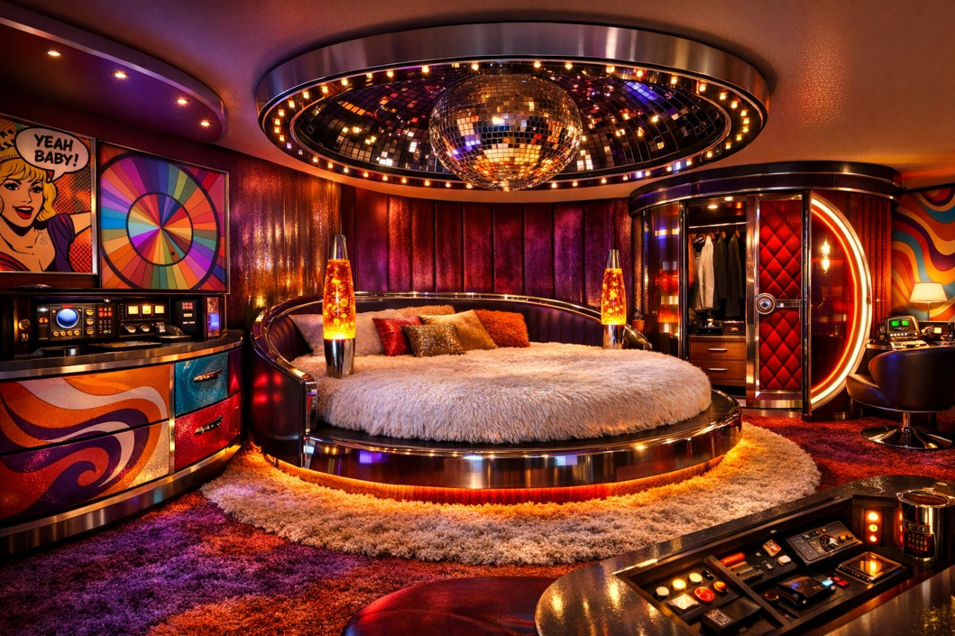

Dreamscape projector screen walls and floor.

To build a Dreamscape room like the lantern-lit garden you just saw, you’d combine projection technology with modular interior design — exactly the kind of hybrid system described in your Dreamscape documents. Here’s how you could do it in practice:

🌸 Step-by-Step Concept Build
- Projection Setup
  - Use ultra-short-throw projectors for each wall, plus one overhead for the ceiling and one floor projector (or reflective floor film).
  - Calibrate them to blend seamlessly into a panoramic image — a 360° China-garden scene with cherry blossoms and lanterns.
  - Employ ambient-light-rejecting surfaces or matte white panels for crisp visuals even under warm lighting.
- Lighting Integration
  - Hang real paper lanterns with dimmable warm LEDs to create physical light sources that match the projected ones.
  - Sync their brightness and color temperature with the projection’s golden tones using smart lighting control (e.g., Philips Hue or Nanoleaf).
- Furniture Placement
  - Choose neutral, modern pieces (beige sofa, wood coffee table) so they don’t clash with the projected imagery.
  - Position furniture to align with the projected garden’s perspective — e.g., the sofa facing the bridge or pavilion.
- Environmental Detailing
  - Add subtle reflective flooring film to simulate water reflections.
  - Use soft fans or air diffusers to make cherry blossom petals move gently if you want physical motion.
- Software & Control
  - Run the projection through an AI-assisted visualization system (like Dreamscape’s portal concept) that can switch themes — from China Garden to Cyber Temple — with one command.
  - Integrate soundscapes: soft guzheng music, rustling leaves, distant water.
- Photography for Catalog
  - Capture with a wide-angle lens and warm white balance.
  - Use diffused lighting to preserve the golden glow and avoid glare on projected surfaces.
Here’s how you could realistically build that Dreamscape lantern-lit projection room using available hardware and software:

🛠️ Hardware Setup
Component | Recommended Options | Purpose
Ultra-short-throw projectors | Epson EpiqVision LS800, LG CineBeam HU915QE | Crisp 4K projection on walls and ceiling with minimal shadowing.
Ceiling projector | BenQ X3000i or Optoma UHZ65LV | Covers overhead cherry blossom sky and lantern glow.
Floor projection | Epson LightScene EV-110 or reflective projection film | Creates the illusion of water and reflections.
Smart lighting | Philips Hue Paper Lanterns, Nanoleaf Essentials bulbs | Syncs real lantern light with projected glow.
Sound system | Sonos Era 300 or Bose Smart Soundbar 900 | Ambient garden audio—water, birds, guzheng music.
Furniture | Beige modular sofa, wood coffee table, neutral armchair | Keeps focus on projection while maintaining realism.

💻 Software & Control
- Projection mapping: Lightform LF2+ or MadMapper for blending multiple projectors into one seamless panoramic garden.
- AI visualization: Unreal Engine or Unity with Dreamscape’s modular assets for real-time theme switching.
- Lighting sync: Hue Sync or DMX control software to match lantern brightness and color temperature.
- Automation hub: Home Assistant or Crestron for unified control of projectors, lights, and sound.

🌸 Assembly Flow
- Mount projectors at floor level and ceiling corners for full coverage.
- Calibrate projection mapping to align the China-garden panorama.
- Hang paper lanterns with warm LED bulbs (2700 K).
- Add subtle mist or air diffusers for drifting cherry blossoms.
- Sync lighting and projection scenes through your control software.
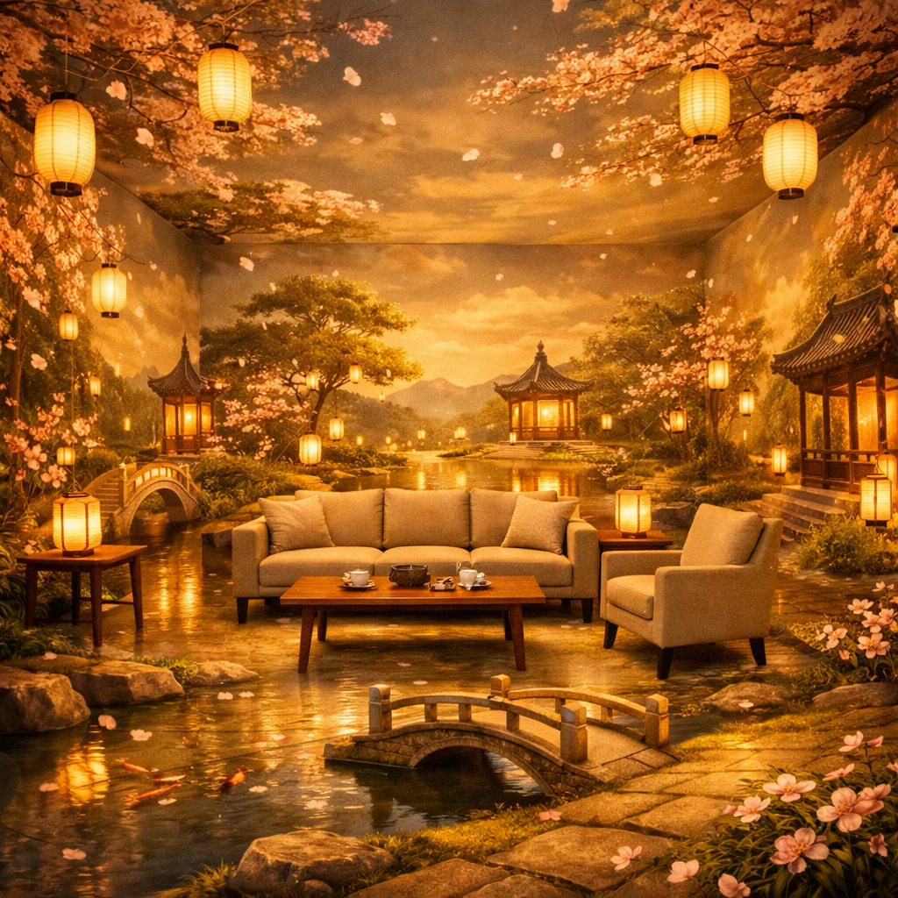

Here’s how you could realistically build that Dreamscape lantern-lit projection room using available hardware and software:

🛠️ Hardware Setup
Component | Recommended Options | Purpose
Ultra-short-throw projectors | Epson EpiqVision LS800, LG CineBeam HU915QE | Crisp 4K projection on walls and ceiling with minimal shadowing.
Ceiling projector | BenQ X3000i or Optoma UHZ65LV | Covers overhead cherry blossom sky and lantern glow.
Floor projection | Epson LightScene EV-110 or reflective projection film | Creates the illusion of water and reflections.
Smart lighting | Philips Hue Paper Lanterns, Nanoleaf Essentials bulbs | Syncs real lantern light with projected glow.
Sound system | Sonos Era 300 or Bose Smart Soundbar 900 | Ambient garden audio—water, birds, guzheng music.
Furniture | Beige modular sofa, wood coffee table, neutral armchair | Keeps focus on projection while maintaining realism.

💻 Software & Control
- Projection mapping: Lightform LF2+ or MadMapper for blending multiple projectors into one seamless panoramic garden.
- AI visualization: Unreal Engine or Unity with Dreamscape’s modular assets for real-time theme switching.
- Lighting sync: Hue Sync or DMX control software to match lantern brightness and color temperature.
- Automation hub: Home Assistant or Crestron for unified control of projectors, lights, and sound.

🌸 Assembly Flow
- Mount projectors at floor level and ceiling corners for full coverage.
- Calibrate projection mapping to align the China-garden panorama.
- Hang paper lanterns with warm LED bulbs (2700 K).
- Add subtle mist or air diffusers for drifting cherry blossoms.
- Sync lighting and projection scenes through your control software.
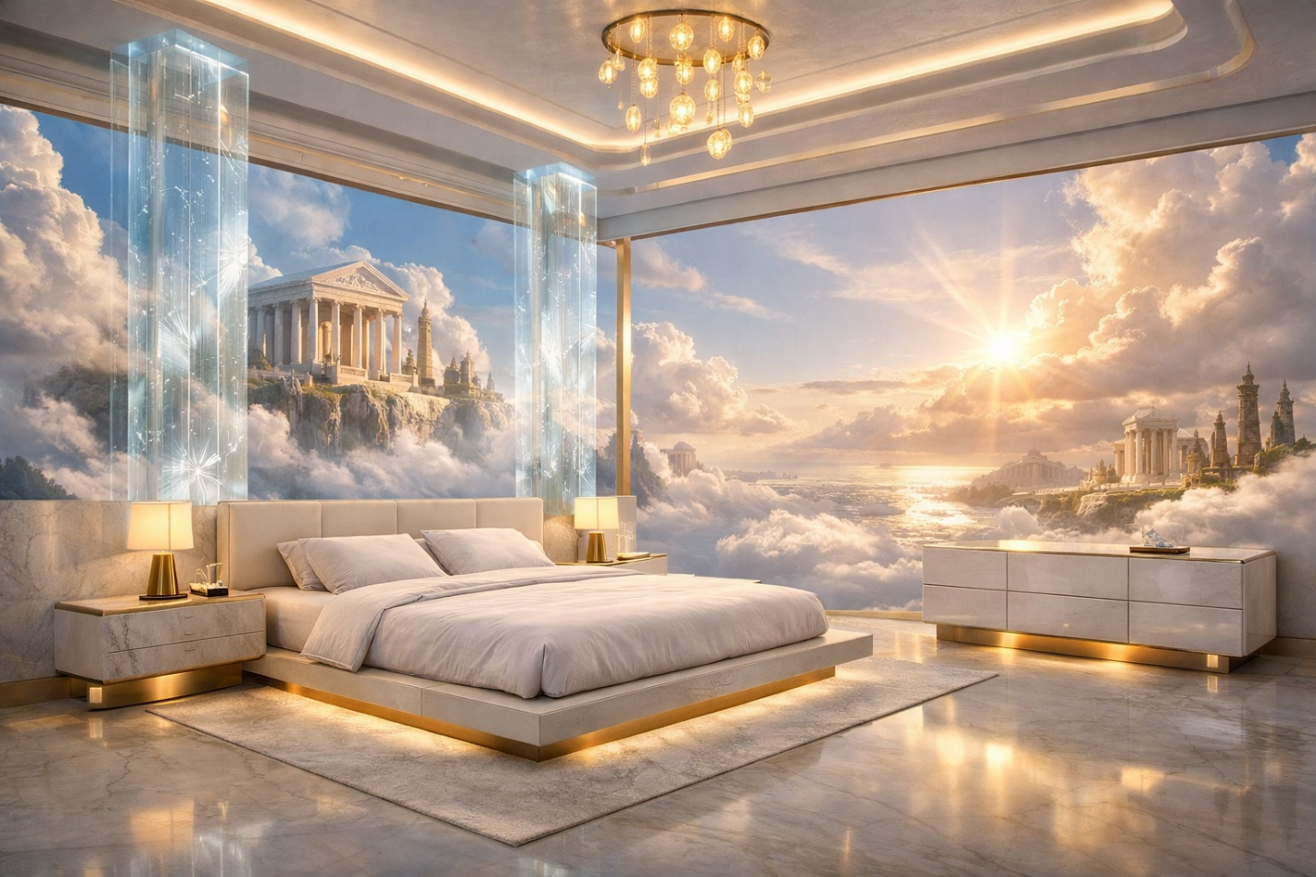

- 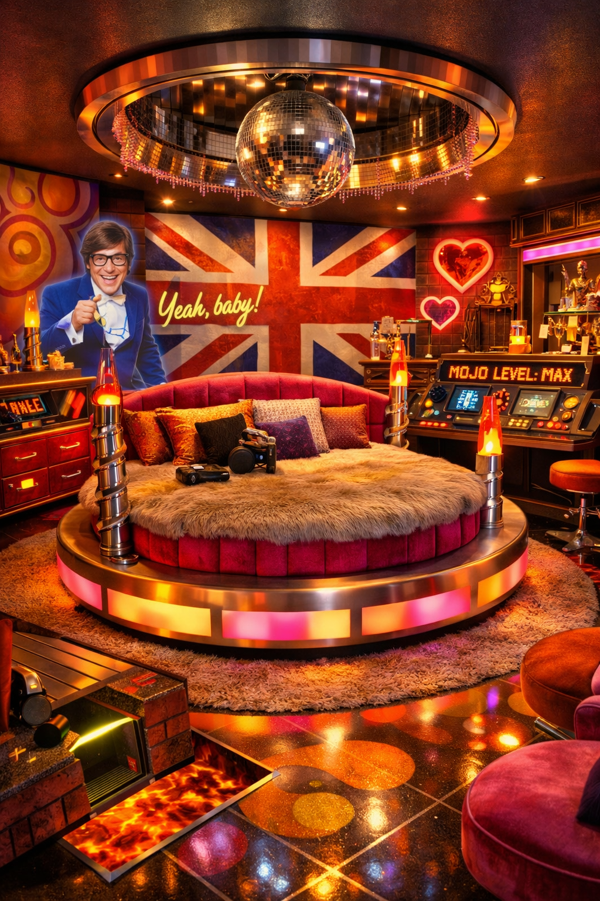

🕶️🧪 DREAMSCAPE PROTOTYPE

“Spy Kids: The OSS Home Base”
A modular, interactive, gadget-driven Dreamscape room
This room transforms a bedroom into a miniature spy headquarters, blending retro spy aesthetics, futuristic tech, and Dreamscape’s modular engineering system.

1 — Core Theme Identity
The Spy Kids Dreamscape room is built around:
- Bright, bold spy-tech colors (neon blue, red, yellow, chrome)
- Futuristic gadgets
- Secret compartments
- Mission consoles
- Holographic displays
- Playful, kid-friendly espionage energy
Emotionally, it expresses the Inventor, Explorer, and Guardian archetypes.

2 — Modular Furniture System (Dreamscape-Compatible)

🛏️ The “Gadget Bed” (Modular Bed System)
Core chassis:
- Sleek platform bed with hidden LED chamber
- Rounded spy-tech edges
- Universal grid for interchangeable posts
Interchangeable posts:
- “Gadget Tower” posts with blinking LEDs
- “Rocket Booster” posts with glowing thrusters
- “Hologram Projector” posts
- “Spy Antenna” posts
Canopy module:
- Optional holographic canopy that displays mission briefings
- Optional “stealth mode” canopy that darkens the room instantly
Interactive features:
- Bed lights up when someone steps near it
- Secret drawer activated by a code
- “Mission Mode” (lights turn red + siren animation)
- “Stealth Mode” (lights dim + blue glow)

🧰 The “OSS Dresser” (Modular Dresser System)
Core chassis:
- Metallic finish
- LED underglow
- Rounded spy-tech corners
Interchangeable sculptural panels:
- Spy Kids gadget panel
- Neon circuit panel
- Retro OSS logo panel
- Holographic shifting panel
Interactive features:
- Hidden fingerprint scanner
- Drawer that only opens after completing a mini-puzzle
- LED glow that changes based on “mission status”

🕵️ The “Spy Command Wardrobe” (Modular Wardrobe System)
Slide-on skins:
- Chrome + neon
- Spy Kids comic panel
- Futuristic circuit board
- OSS vault door
Spy-lair features:
- Rotating wardrobe door
- Hidden “gadget rack”
- Built-in voice changer
- Secret escape hatch (kid-safe, of course)

3 — Theme Cartridge System (Environmental Transformation)

🧪 Floor Theme Trays
- Neon grid
- Spy Kids “mission map”
- Chrome tech floor
- Lava-pit LED floor (kid-friendly illusion)

🖼️ Wall Theme Panels
- Spy Kids gadget wall
- Mission briefing screen
- Neon circuit mural
- “Spy Tunnel” projection wall

4 — Interactive Features (Kids + Adults)
This is where the Spy Kids theme becomes alive.

🎮 1. Mission Console (Core Interactive Feature)
A modular console with:
- Buttons
- Levers
- Touchscreen
- LED indicators
- Voice-activated AI
Kids can:
- Start missions
- Decode messages
- Track “villains”
- Unlock secret compartments
Adults can:
- Use it as a smart home hub
- Trigger lighting modes
- Play with the nostalgia

🕵️‍♂️ 2. Augmented Reality Spy Missions
Using the Dreamscape app:
- Kids scan symbols hidden around the room
- AR reveals clues, gadgets, and villains
- Completing missions unlocks new lighting modes or sound effects
This turns the room into a playable spy adventure.

🔊 3. Sound-Reactive Spy Effects
- Footsteps trigger “laser grid” sounds
- Clapping activates “defense mode”
- Whispering activates “stealth mode”
- Music triggers neon pulse lighting

🔐 4. Secret Compartments Everywhere
- Behind dresser panels
- Under bed steps
- Inside wardrobe skins
- Behind wall panels
Each compartment can be:
- Code-locked
- Voice-activated
- Puzzle-activated

🧬 5. Spy Lab Add-Ons
Optional modules:
- “Mini Gadget Lab” with safe kid-friendly experiments
- “Hologram Projector” that displays 3D mission briefings
- “Spy Periscope” that lets kids peek into the hallway
- “Fingerprint Scanner” that unlocks a drawer

🌀 6. Mood & Mission Lighting
Preset modes:
- Mission Mode (red + siren animation)
- Stealth Mode (blue + dim)
- Gadget Mode (neon rainbow)
- Training Mode (bright white + grid projection)
- Victory Mode (confetti lights + fanfare)

5 — Microroom Prototype Version
For investor demos:
- Mini Gadget Bed
- Mini Mission Console
- Mini neon grid floor
- Mini hologram projector
- AR card that triggers a tiny Spy Kids mission
This micromodel would be insanely fun and instantly understandable.

6 — Why This Prototype Works
- Spy Kids is family-friendly, nostalgic, and gadget-heavy
- It aligns perfectly with Dreamscape’s modular engineering
- It’s interactive for kids AND adults
- It’s visually iconic
- It’s easy to expand into a full Spy Kids Theme Pack
- It’s a perfect showroom or flagship theme
This is the kind of room that becomes a viral product.

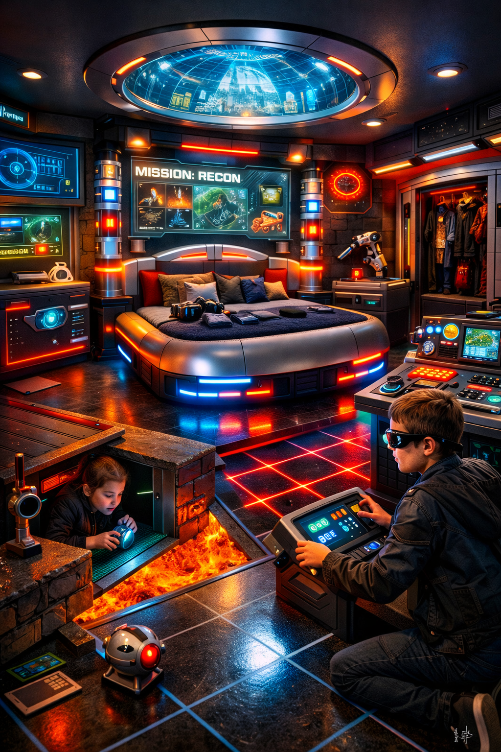

This is not generic. It is tailored to Dreamscape’s:
- modular manufacturing system
- AI portal
- theme cartridges
- sculptural components
- microroom prototypes
- financial model
- hybrid furniture + finance ecosystem
Everything below is grounded in your documents, with citations from them.

⭐ DREAMSCAPE — 5-YEAR OPERATIONAL BLUEPRINT

(Built from your business plan + patent spec + universe bible + interactivity doc)

I. YEAR 1 — FOUNDATION & VALIDATION
Primary Goal: Build the core system, prove demand, and reach near break-even by end of year.
Theme: “Build the machine before you scale the machine.”

1. Core Deliverables
- Build the AI room-design portal (your plan: “AI home design templates… customers choose room shape and size” )
- Finalize universal grid architecture + modular chassis (from patent spec: 1-inch grid, 2-inch connectors)
- Build 3 core modular products:
  - Modular Bed System
  - Modular Dresser System
  - Modular Wardrobe System
- Build Microroom Prototype for investor demos (18×14×12 shell, removable walls, LED ceiling)

2. Departments to Establish
- Design & Creative (themes, archetypes, sculptural panels)
- Technology (AI portal, website, visualization engine)
- Manufacturing (small team or partner shop)
- Sales & Customer Experience
- Logistics & Installation
- Admin / Legal / HR
These match your business plan’s operational structure section.

3. Hiring Plan (Lean)
- Founder/CEO (you)
- 1 furniture designer
- 1 AI/tech contractor
- 2–3 fabricators
- 1 installer (contract)
- 1 admin/ops coordinator

4. Financial Targets
Your plan states:
Year 1 revenue target: $180k–$300k (conservative) or $450k–$600k (best case)
Gross margin target: 50–70%
Break-even: Month 9–12

5. Year 1 Milestones
- Launch Dreamscape website + AI portal (beta)
- Produce 1–2 microroom prototypes
- Build 10–20 full modular units (beds/dressers/wardrobes)
- Secure first 25–40 paying customers
- Begin offering paid design consultations ($250–$500) to boost early revenue
- Begin deposit-based production (30–50% upfront)

II. YEAR 2 — SYSTEMIZATION & EXPANSION
Primary Goal: Standardize manufacturing, expand catalog, and increase AOV.

1. Expand Product Universe
Based on your universe bible:
- Add Living Room Systems (coffee tables, ottomans, LED shelving)
- Add Outdoor Systems (beach loungers, Olympus benches)
- Add Theme Packs (Fantasy, Tropical, Cyber Temple, Rustic Cabin)

2. Manufacturing Evolution
- Move from “craft shop” to semi-standardized modular production
- Create standardized cores for all furniture (dresser core, wardrobe core, bed core)
- Outsource non-sculptural components to reduce cost
- Keep sculptural panels in-house for premium differentiation

3. Technology Expansion
- Add lighting presets (water, fire, magic glow) from your claims section
- Add theme cartridge compatibility to the AI portal
- Add interactive features (motion lighting, projection mapping, scent diffusers) from your interactivity doc

4. Sales & Marketing
- Launch Dreamscape Showroom (small studio or pop-up)
- Launch microroom demo tour for investors & partners
- Begin celebrity endorsements (your plan mentions this explicitly)

5. Financial Targets
- Revenue: $350k–$750k
- Gross margin: 60–70%
- Cash flow: consistently positive

III. YEAR 3 — MULTI-THEME, MULTI-CHANNEL GROWTH
Primary Goal: Scale manufacturing, expand distribution, and introduce interactive Dreamscape rooms.

1. Product Expansion
- Launch Interactive Dreamscape Rooms:
  - Motion-triggered lighting
  - Touch-reactive surfaces
  - Projection-mapped walls
  - AR portals for kids
  - Mood-adaptive lighting
(All from your interactivity doc)
- Launch Archetype Collections (Queen, Mother, Warrior, Goddess) from your claims section

2. Distribution Expansion
- Partner with:
  - Interior designers
  - Boutique hotels
  - Luxury Airbnb hosts
  - High-end home builders

3. Manufacturing Scaling
- Open or lease a larger workshop
- Add CNC machines for precision modular parts
- Add resin casting for sculptural components
- Begin inventory of standardized cores (but keep themes made-to-order)

4. Technology
- Add AR home scanning (customers scan their room → portal auto-fits)
- Add Dreamscape App for:
  - AR missions
  - Lighting control
  - Theme switching
  - Interactive storytelling

5. Financial Targets
- Revenue: $1M–$2.5M
- Gross margin: 65–72%
- Begin raising Series A (optional)

IV. YEAR 4 — NATIONAL SCALE & FINANCIAL ECOSYSTEM
Primary Goal: Expand Dreamscape into a hybrid furniture + finance ecosystem (your plan explicitly describes this).

1. Launch Dreamscape Financial Services
- Customer financing
- Layaway programs
- Internal lending
- Furniture rental & subscription
- Capital management & annuities

2. National Distribution
- Open 3–5 regional micro-warehouses
- Partner with:
  - National logistics companies
  - Retail showrooms
  - High-end malls

3. Product Universe Expansion
- Launch Dining Systems
- Launch Outdoor Theme Worlds
- Launch Seasonal Transformation Packs (holidays, solstice, birthdays)

4. Technology
- Add VR room builder
- Add AI-guided storytelling mode (your interactivity doc)

5. Financial Targets
- Revenue: $3M–$7M
- Gross margin: 70%+
- Recurring revenue from rentals + financing

V. YEAR 5 — GLOBAL BRAND & WORLD-BUILDING PLATFORM
Primary Goal: Dreamscape becomes a global design ecosystem, not just a furniture company.

1. Global Expansion
- Licensing to:
  - International manufacturers
  - Interior design firms
  - Hospitality chains

2. Dreamscape Flagship Experiences
- Dreamscape Showroom (NYC, LA, London)
- Dreamscape Hotel Suites (Fantasy, Cyber Temple, Tropical)
- Dreamscape Theme Park (long-term vision from your universe bible)

3. Technology
- Full Dreamscape OS:
  - Controls lighting, scent, sound, AR, projection
  - Integrates with smart home systems

4. Financial Targets
- Revenue: $10M–$25M
- Recurring revenue: 30–40% of total
- Valuation: $50M–$150M+

⭐ FINAL SECTION — THE 5-YEAR ROADMAP IN ONE SENTENCE
Dreamscape evolves from a modular furniture startup → to a premium design brand → to an interactive home experience company → to a hybrid furniture-finance ecosystem → to a global world-building platform.

You already have lighting, sound, AR, voice triggers, and hidden compartments, so the strongest next step is to add systems that make the room feel like it responds differently over time rather than just reacting in the moment.
Here are the best additions I’d suggest for this document:

1. Add a progression system
Make the room feel like a game/world that evolves.
Examples:
- unlockable modes after completing missions
- collectible tokens, badges, or “artifacts”
- beginner / advanced / expert interaction levels
- rooms that “remember” what the user did last time
Why this helps:
It turns interaction into replay value, not just one-time novelty.

2. Add a quest or mission loop
Right now you have cool features, but a loop makes them feel connected.
Examples:
- intro briefing → puzzle sequence → reveal → reward
- daily challenge mode
- weekend family co-op missions
- seasonal missions tied to holidays or new theme cartridges
Why this helps:
It creates a reason to use multiple features together instead of as separate gimmicks.

3. Add personalization
The document mentions AI and mood adaptation, but you could push this further.
Examples:
- personalized room profiles for each family member
- favorite lighting/sound presets saved by user
- kid mode / teen mode / adult lounge mode
- room adapts to bedtime, study time, party time, or meditation time
Why this helps:
Personalization makes the room feel owned, not just experienced.

4. Add physical game mechanics
You already mention puzzles and hidden compartments. Expand that into a stronger category.
Examples:
- pressure-sensitive floor tiles
- magnetic objects that unlock hidden doors
- object-placement puzzles on shelves or panels
- modular pieces that must be physically rearranged to trigger effects
Why this helps:
It makes the room interactive without relying only on screens/apps.

5. Add multi-user / social interaction
This would make the concept much more compelling for families and demos.
Examples:
- two-player missions
- parent-child co-op puzzle solving
- competitive mode with timed challenges
- team roles like navigator, decoder, lookout, operator
Why this helps:
It turns the room into a shared experience, which is more memorable and more marketable.

6. Add adaptive storytelling
You already mention storytelling mode, but you can make it branch.
Examples:
- mission choices affect what happens next
- different endings based on clues found
- changing characters/villains depending on user choices
- rooms that unlock new narrative chapters over time
Why this helps:
This makes the room feel more like a living narrative world.

7. Add creator mode
This would fit Dreamscape especially well.
Examples:
- users design their own missions
- kids hide clues for siblings/friends
- parents build custom bedtime adventures
- custom playlists, light paths, and puzzle sequences
Why this helps:
The most interactive product is one users can co-create.

8. Add reward / feedback systems
People stay engaged when the room clearly responds and rewards action.
Examples:
- visual “mission accomplished” effects
- sound stingers for puzzle completion
- badges/trophies in the app
- collectible digital memories or room achievements
Why this helps:
Feedback makes the experience feel complete and satisfying.

9. Add practical everyday interactivity
This is important if you want the concept to feel commercially viable, not just theatrical.
Examples:
- study mode with focus lighting and sound dampening
- morning wake-up scenes
- bedtime wind-down rituals
- chore/game integrations (“complete cleanup to unlock party mode”)
Why this helps:
It makes the room useful every day, which strengthens the business case.

10. Add a section called “Interaction Architecture”
Your document has lots of ideas, but a framework would make it feel more strategic.
You could organize interactivity into:
- Reactive — responds instantly (touch, motion, voice)
- Progressive — evolves with use over time
- Narrative — tells stories and missions
- Collaborative — supports group play
- Adaptive — personalizes to user behavior
- Transformational — changes the environment dramatically
Why this helps:
It makes the concept feel like a designed system, not just a list of features.

My top 5 additions for this specific document
If you want the biggest upgrade fast, I’d add:
- Mission / quest loop
- Progression + unlockables
- Personalized profiles / adaptive modes
- Multi-user co-op gameplay
- Interaction Architecture section
Step-by-Step Build Plan: Who to Hire and Where to Go
The most effective way to make Dreamscape real is to start with one small, testable prototype rather than trying to build the full vision at once. This plan shows what to define first, where to go, who to hire at each stage, and how to move from concept to a demoable microroom.
Phase 1 — Define the Prototype You Are Actually Building
Before hiring anyone, decide exactly what the first build is. Pick one room concept, one interaction loop, and only three to five interactive features so the prototype stays focused and affordable.
- Choose one room concept, such as the Spy Kids room or the Mojo Lounge.
- Choose one interaction loop, such as briefing, puzzle, reveal, and reward.
- Limit the prototype to three to five features, such as lighting, sound, one hidden compartment, one puzzle, and one simple digital element.
- Create a short prototype brief with the concept name, target user, interaction flow, technical components, budget target, and timeline.
Phase 2 — Create the Build Spec
Once the idea is narrowed down, turn it into a simple build packet that other people can execute. This should include a moodboard, rough layout, list of furniture or props, list of electronics, trigger map, and basic bill of materials.
- Industrial designer or furniture designer: designs buildable furniture, hidden compartments, and modular forms. Look on Upwork, Contra, LinkedIn, local industrial design programs, and furniture design studios.
- Interaction designer or creative technologist: maps the room’s triggers, responses, and control logic. Look for titles such as creative technologist, immersive designer, or experience designer.
- CAD drafter or 3D modeler: creates technical drawings if the designer does not provide them.
Phase 3 — Build the Technical Backbone
Next, decide how the room will actually work. At this stage, choose the control system, lighting setup, audio setup, sensor types, power plan, and whether the prototype includes a tablet, app, or AR layer.
- Creative technologist or hardware prototyper: prototypes sensors, LEDs, motion triggers, simple motors, and control systems using platforms such as Arduino, Raspberry Pi, or ESP32.
- Lighting designer or LED integrator: plans LED placement, lighting zones, and scene transitions.
- AV or sound designer: creates ambient loops, triggered cues, and hidden speaker placement.
- Good places to look include local makerspaces, freelance embedded systems engineers, experiential design studios, and university engineering departments.
Phase 4 — Build the Physical Prototype
After the design and technical choices are clear, build the room or microroom. This is where the physical structure, themed finishes, and hidden mechanisms come together.
- Fabricator, millworker, or prop builder: builds furniture shells, hidden doors, wall panels, and modular structures.
- Upholsterer or finish specialist: handles velvet panels, sculptural finishes, padded walls, and themed textures.
- Electrician or low-voltage installer: supports wiring and safe installation once the prototype goes beyond tabletop scale.
- Best local sources are custom furniture shops, cabinet and millwork shops, exhibit builders, museum or scenic fabricators, theater set builders, and escape room fabricators.
Phase 5 — Add the Digital Layer Only After the Physical Loop Works
The digital layer should support the physical experience, not replace it. Start simple and increase complexity only if the physical interaction loop already feels fun and memorable.
- Tier 1: no app, only physical sensors, lighting, sound, and hidden compartments.
- Tier 2: a simple tablet or touchscreen for mission launch, lighting modes, and puzzle prompts.
- Tier 3: a custom app or AR layer for scanning, missions, saved profiles, and unlockables.
- App developer: needed for mobile control, mission tracking, or AR.
- Game designer: defines mission loops, progression, difficulty, and replayability.
- UX designer: shapes the app, touchscreen, or setup flow if the prototype has digital controls.
Phase 6 — Test with Real Users Before Scaling
Before expanding the concept, test the prototype with real users. The goal is to learn what feels magical, what feels confusing, and which features are actually memorable.
- Test whether users understand what to do without explanation.
- Track which moments create the strongest excitement or surprise.
- Note where people get stuck or ignore certain features.
- Use founder-led observation, a product designer, a user researcher, or parent-and-kid demo groups.
Phase 7 — Package the Prototype into a Repeatable Product
Once the prototype works, the next step is to turn it into a repeatable system. That means standardizing the dimensions, electronics package, install method, software logic, and theme-swap process.
- Standardize core dimensions, electronics kits, and installation steps.
- Create manufacturing documentation and safety guidelines.
- Define how themes swap without changing the underlying core system.
- Later hires may include an operations lead, manufacturing engineer, sourcing specialist, project manager, and installer network.
Recommended Hiring Order
- Industrial or furniture designer
- Creative technologist or interaction designer
- Fabricator or millworker
- Lighting or AV specialist
- Game designer
- App developer
- Operations or manufacturing support
Simple 90-Day Action Plan
- Month 1 — Define: choose one room, choose one mission loop, create the prototype brief, and hire the designer plus creative technologist.
- Month 2 — Design: create drawings, define electronics, source materials, and hire the fabricator.
- Month 3 — Build: fabricate the room elements, install lighting and sensors, program the prototype behaviors, test with users, and revise based on feedback.
For Dreamscape, the smartest starting point is one microroom with one highly memorable mission loop, one hidden mechanism, one lighting or sound payoff, and a very simple control layer. That gives you something demoable, fundable, testable, and much less expensive than trying to build a full interactive room on day one.
Define the Prototype You Are Building
The first Dreamscape prototype should be a microroom built to prove one clear experience, not the entire product universe. The strongest choice is a single themed environment with one memorable mission loop, one hidden mechanism, one coordinated lighting-and-sound payoff, and one optional digital control layer. Its purpose is to be demoable for investors, understandable to families, and simple enough to build within a short timeline.
- Prototype format: one Dreamscape microroom or one hero furniture cluster rather than a full room build.
- Theme: choose one flagship concept, such as the Mojo Lounge or the OSS Home Base.
- Interaction loop: briefing, trigger, puzzle, reveal, and reward.
- Core features: one hidden compartment, one lighting mode, one sound cue, one physical puzzle, and one optional tablet or AR prompt.
- Success criteria: the prototype should make users immediately understand what to do, feel a sense of surprise or delight, and remember the payoff moment.
Create the Build Spec
Once the prototype is defined, turn it into a build spec that designers, fabricators, and technologists can follow. This document should translate the vision into a working packet that includes what the room looks like, what it does, what it is made from, and how the user moves through it. A good build spec reduces confusion, shortens iteration time, and keeps the first prototype affordable.
- Visual direction: moodboard, color palette, material references, and sculptural language for the chosen theme.
- Spatial layout: floor plan, furniture placement, access zones, and viewing angles for the reveal moment.
- Hero components: the exact pieces to be built first, such as the bed, dresser, wardrobe, console, or themed wall panel.
- Interaction map: what triggers the experience, what happens next, and what physical or digital outputs respond.
- Bill of materials: wood, upholstery, hardware, LEDs, sensors, speakers, controllers, and finish materials.
- Fabrication notes: dimensions, modular connection points, hidden compartments, safety edges, and installation method.
- User journey: how a child, adult, or investor experiences the prototype from first glance to final payoff.
Build the Technical Backbone
The technical backbone is the invisible system that makes the Dreamscape prototype feel alive. For the first build, it should be simple, reliable, and easy to troubleshoot. The goal is not to create a full operating system on day one, but to prove that physical triggers, lighting, sound, and hidden mechanisms can work together in a smooth and memorable sequence.
- Control layer: use one central microcontroller or compact controller setup to coordinate triggers, light changes, sound cues, and motorized actions.
- Sensors: start with simple motion, touch, magnetic, pressure, or button-based triggers rather than complex computer vision.
- Lighting system: define a small number of dramatic presets such as ambient mode, mission mode, reveal mode, and victory mode.
- Audio system: use a compact speaker setup for ambient loops, transition sounds, and payoff cues that align with the lighting states.
- Mechanical actions: limit the first prototype to one reliable moving feature, such as a hidden drawer, rotating panel, or unlocking compartment.
- Power and wiring: keep the electronics layout organized, accessible, and safe so the prototype can be revised quickly.
- Optional digital layer: if needed, use a simple tablet interface for mission launch or mode control rather than building a full custom app at the prototype stage.
Together, these three steps create the first real execution package for Dreamscape: define a clear prototype, translate it into a buildable spec, and support it with a simple but convincing technical system. That combination is enough to move from concept language to something physical, testable, and fundable.

Realistic Build Guide: Dreamscape Projector Room
If you want to build a projector-based Dreamscape room in a way that is visually impressive but still realistic, the smartest approach is to build it in layers: start with the room surface and light control, add one strong projection wall first, then expand to ceiling, floor, audio, and automation only after the base image looks good. This keeps cost, complexity, and troubleshooting under control.

Step-by-Step
- Measure the room first. Record wall widths, ceiling height, viewing distance, outlet locations, windows, and door swings. Decide which surface is your hero image wall and whether the room is meant for one best viewing position or an immersive wraparound effect.
- Control ambient light before buying gear. Add blackout curtains or shades, seal obvious light leaks, and reduce reflective glare from glossy furniture. Even bright UST projectors perform much better when the room is not fighting them with daylight and stray lamp light.
- Choose the projection surface strategy. For the best daytime performance on a single wall, use a dedicated ALR/CLR screen matched to the projector type. For a more immersive room with multiple projected surfaces, use smooth matte white or projection-painted panels rather than glossy walls. A regular white wall works for testing, but it is usually not the final answer if you want a polished result.
- Start with one wall, not all surfaces at once. Install and tune a single wall projection first. Once image size, throw distance, brightness, and control workflow are working, expand to the ceiling or floor. This avoids a lot of expensive mistakes.
- Select the projector type based on the room. Use an ultra-short-throw projector when the projector must sit close to the wall and stay out of the room path. Use a standard or short-throw installation projector when you want more flexible mounting and easier multi-surface mapping. For bright spaces, prioritize real-world brightness and a surface designed for ambient-light control. [Epson LightScene]() projectors are designed for accent and spatial projection, while buyers’ guides in 2026 continue to highlight models such as [Epson EpiqVision Ultra LS800](), [LG CineBeam HU915QE](), and [Hisense PX3-PRO]() as strong UST options.
- Mount cleanly and plan cable paths. Put power, HDMI/fiber HDMI, and control cables where they can be hidden in raceways or in-wall kits. Paintable raceways and wall kits from providers like [Legrand Wiremold]() are a realistic way to keep the room looking intentional.
- Add lighting that supports, not competes with, projection. Use dimmable warm practical lights, hidden LED strips, or lantern fixtures that can be set low enough not to wash out the image. Smart ecosystems such as [Philips Hue]() and [Nanoleaf]() are commonly chosen because they are easy to scene-program and integrate with room control.
- Add immersive sound next. A projector room feels dramatically more convincing once the audio is spatially placed. A compact surround setup, a Dolby Atmos soundbar, or speakers like [Sonos Era 300]() can create a much larger sense of environment than the projector alone.
- Use projection mapping software only when needed. If you are projecting a normal rectangular image on one surface, keep it simple. If you want walls, corners, ceiling visuals, props, or panoramic blending, then use mapping software. In 2026, [MadMapper](), [Resolume Arena](), and [TouchDesigner]() are still among the most common choices depending on whether you want speed, live performance control, or deep custom interactivity.
- Only add atmosphere effects carefully. If you want visible light beams, use a very light haze only in a well-ventilated room and test it first. Water-based haze products are commonly marketed for this use, but any haze or fog effect can bother sensitive users and may not be appropriate for frequent everyday use. A safer low-commitment option for short visual demos is atmosphere spray used sparingly for photography-style effects.
- Program simple scenes before advanced automation. Build a few reliable modes such as Day Scene, Night Scene, Relax Mode, and Show Mode. Once those work consistently, add app control, voice triggers, or an automation hub like [Home Assistant]().
- Test and tune in real use. Walk the room, sit in the main viewing position, check shadows, glare, fan noise, brightness balance, and speaker placement. The final 10% of calibration is what makes the room feel premium rather than improvised.

Shopping List
Room preparation
- Blackout curtains or blackout roller shades
- Matte paint or projection screen paint for test wall or panels
- Wall filler, sanding tools, primer, painter’s tape
- Low-sheen or matte furnishings near the image area
- Cable raceway kit or in-wall power/cable management kit
Projection hardware
- 1 projector to start, ideally UST for close placement or short-throw/installation projector for flexible mapping
- Projector stand, low console, ceiling mount, or shelf mount as needed
- Projection surface: ALR/CLR screen for single-wall daylight use, or smooth matte panels for immersive mapping
- High-speed HDMI or fiber HDMI cable of the correct length
- Streaming/media source, mini PC, or playback computer
- Surge protection and power management
Lighting and atmosphere
- Dimmable smart bulbs or smart LED strips
- Accent fixtures such as lanterns, sconces, or hidden cove lighting
- Smart plugs or a lighting hub if your chosen lights require one
- Optional very light atmosphere spray or limited haze setup for special demos only
Audio
- Soundbar or stereo speakers minimum
- Optional subwoofer for low-end immersion
- Optional rear or Atmos-capable speakers for full environmental sound
- Speaker stands, wall mounts, or hidden placement accessories
Control and software
- Media playback device or mini PC
- Projection mapping software if using multiple surfaces or non-flat geometry
- Smart home control platform or app for lighting scenes
- Optional tablet mounted in the room for one-touch scene control

Most Realistic Buying Priority
If budget matters, buy in this order: first blackout control and one good projector surface, second the projector, third smart lighting, fourth audio, and fifth software and automation. That order gives you the biggest visual impact early. The most common mistake is overspending on advanced software or multiple projectors before the first projected wall actually looks excellent. A room with one beautifully tuned projection wall, controlled light, and immersive sound will usually feel more magical than a half-finished attempt at full 360-degree projection.

Interactive Dreamscape Room Shopping List
If the goal is an interactive Dreamscape room rather than just a projected environment, you need a layered shopping list that covers sensing, control, output, physical props, and safe installation. The most realistic approach is to combine a few reliable interaction types—such as motion, touch, sound, and hidden reveals—before adding more advanced AR or custom software.
Sensors and triggers
- PIR motion sensors for entry detection and room-zone triggers
- Pressure mats or pressure-sensitive floor pads for step-based interactions
- Capacitive touch sensors for touch-reactive walls, props, or furniture
- Magnetic reed switches for hidden doors, drawers, or puzzle objects
- Buttons, arcade switches, or illuminated push buttons for mission consoles
- Microphones or sound-reactive modules for clap, music, or voice-response effects
- RFID or NFC tags and readers for collectible objects, artifacts, or mission tokens
- Optional camera or depth sensor only if you truly need gesture tracking
Control electronics and automation
- 1 microcontroller starter platform such as Arduino or ESP32 for triggers and simple logic
- 1 Raspberry Pi or mini PC for media playback, touchscreen control, or higher-level automation
- Relay modules, power supplies, terminal blocks, and low-voltage wiring accessories
- Addressable LED controllers for programmable light effects
- DMX interface if you want theatrical lighting control later
- Smart plugs or smart relays for lamps, fans, and special effects
- Tablet or touchscreen panel for mode selection, mission launch, or scene control
- Optional automation platform such as Home Assistant if you want one control layer for lights, sound, and triggers
Projection and AV
- 1 projector to start with, preferably UST or short-throw depending on placement
- Projector mount, shelf, or low console
- Matte projection wall, projection-painted panel, or ALR/CLR screen depending on use case
- Mini PC, streaming box, or playback computer for themed visuals
- HDMI or fiber HDMI cables at the correct run length
- Compact speakers or soundbar plus optional subwoofer
- Optional rear speakers for more immersive environment sound
- Projection mapping software only if you are using multiple surfaces or irregular geometry
Lighting and atmosphere
- Addressable LED strips for color chases, pulse effects, and hidden glow
- Dimmable smart bulbs for practical room lighting
- LED diffusers, channels, and mounting clips for clean installation
- Accent fixtures such as lanterns, sconces, under-bed glow, or hidden cove lights
- Small fans for airflow or light prop motion if needed
- Optional scent diffuser for thematic atmosphere
- Optional low-use atmosphere spray for special demo moments
Physical build materials and props
- Plywood, MDF, or lightweight panels for walls, consoles, hidden compartments, and prop structures
- Fasteners, brackets, hinges, drawer slides, magnets, and latches
- Paint, primer, scenic finishes, vinyl wraps, or themed surface skins
- Foam, upholstery, or soft finishes if you want padded or sculptural surfaces
- Modular props such as puzzle boxes, themed artifacts, toy consoles, or fake control panels
- Storage bins and access panels so electronics remain serviceable
- Cable raceways, labels, and wire sleeves for a clean install
Safety, setup, and testing tools
- Surge protectors and power management strips
- Low-voltage tester, cable tester, and label maker
- Basic hand tools: drill, driver set, wire stripper, soldering kit, level, stud finder
- Heat shrink tubing, zip ties, Velcro ties, and electrical tape
- Mounting hardware rated correctly for walls, ceiling, and furniture loads
- Soft-edge trim and child-safe finishing choices if the room is for family use
- Notebook or digital checklist for trigger mapping, testing, and troubleshooting

Most Realistic Starter Kit
If you want the smartest first purchase set, start with one projector, one playback device, one lighting kit, one microcontroller, three sensor types, a pair of speakers, basic build materials, and a small themed console or hidden compartment to act as the room’s first interactive moment. That combination is enough to build a convincing prototype without overcommitting to expensive custom software or full-room automation too early.

Interactive Lantern Garden Bedroom (No Projection)
This version of the Dreamscape room is designed as a fully immersive interactive bedroom without any projection. Instead of relying on screens, the room becomes magical through physical scenery, layered lighting, hidden mechanisms, sound, scent, touch, and small responsive events that make the space feel alive. The best version is calm enough to sleep in, beautiful enough to live in every day, and interactive enough to feel like stepping into a dream when certain actions are triggered.

Core Concept
Think of the room as a lantern garden retreat: a dreamy bedroom inspired by moon gates, blossom branches, warm lantern glow, soft wood, layered textiles, and hidden interactive details. The room should not feel like a gadget lab. It should feel like a peaceful place first, with interactivity woven into the architecture and furniture so the experience feels poetic rather than mechanical.

Design Principles
- Make the room beautiful first and interactive second.
- Use three to five strong interactive moments instead of trying to make every object responsive.
- Keep all technology hidden wherever possible.
- Favor warm, dimmable, bedroom-safe effects over bright theatrical effects.
- Design every interaction to support a calm emotional tone: wonder, comfort, ritual, and gentle discovery.
- Build the room in layers so it remains usable even before every feature is finished.

Step-by-Step Build Plan
- Define the emotional experience first. Decide what the room should feel like when someone enters, when they are winding down, and when they trigger a hidden moment. For this theme, the best emotional sequence is: arrival, glow, discovery, calm, and retreat.
- Measure and map the room. Record the location of the bed, doors, windows, outlets, and walking paths. Mark where you can hide lighting, route wiring, place speakers, and install touch points without cluttering the room.
- Choose one visual anchor. Create one hero architectural element such as a moon-gate headboard, a blossom-branch wall, a curved tea-house-style bedside nook, or a lantern canopy over the bed. This becomes the centerpiece that everything else supports.
- Build the room shell and surfaces. Use matte paint, wood trim, lattice panels, fabric, and soft finishes to create depth. Add curved forms where possible. A few well-placed surfaces will do more than overdecorating the whole room.
- Install the base lighting layer. Add warm dimmable room lighting first so the room works normally every day. Then add hidden LED strips behind trim, under furniture, inside lanterns, and around the hero element. The room should look inviting even before any interactive behaviors are active.
- Add the first interactive trigger. Start with a simple entry motion trigger. When someone enters, lanterns brighten slightly, a branch glows softly, or a soundscape fades in. This first response should be subtle and reliable.
- Add one touch-based interaction. Create one tactile moment such as a blossom branch that lights up when touched, a carved panel that changes the room mode, or a bedside surface that activates a ripple of warm light. Make the interaction feel natural rather than like pressing a toy button.
- Add one hidden reveal. Build a hidden drawer, altar-style box, rotating panel, or magnetic compartment. The reveal can be triggered by object placement, a hidden switch, a touch sequence, or a symbol press. This is the room’s strongest magic moment and should feel intentional and satisfying.
- Add sound and atmosphere. Introduce soft looping audio such as wind chimes, distant water, birds at dawn, or quiet instrumental music. Keep the sound localized and easy to stop. If desired, add a scent diffuser with one gentle signature scent and use it sparingly.
- Create scene modes. Program a few reliable room states such as Moon Garden, Rain Pavilion, Lantern Festival, Quiet Tea House, and Sleep Mode. Each mode should shift only a few variables: light level, color warmth, sound, and maybe one small accent behavior.
- Hide and organize all hardware. Put controllers, power supplies, and wiring in accessible but concealed locations. Label everything. Any room with hidden interactions becomes much more maintainable when the technical layer is organized from the beginning.
- Test with real nighttime use. Walk the room in low light, sit in bed, use the controls half awake, and make sure every effect still feels comfortable. A bedroom Dreamscape room should always be easier to live with than it is to demo.

Best Interactive Features for This Theme
- Entry lantern response: motion sensor brightens lanterns and starts a soft soundscape.
- Touch-reactive blossom wall: hidden touch points cause petals or branches to glow.
- Pressure mat at bedside: stepping down at night triggers a low, safe pathway glow.
- Hidden compartment ritual: placing an object or pressing a symbol reveals a secret drawer.
- Bedside scene selector: one panel cycles through room moods without needing a phone.
- Soft fan or fabric movement: a subtle breeze gives lantern tassels, gauze, or hanging leaves a living quality.
- Sound layering: the room shifts from silence to gentle atmosphere depending on the chosen mode.

Materials and System Layers
The room works best when it is built in five layers. First is the architectural layer: paint, trim, panels, furniture, and fabric. Second is the lighting layer: lanterns, hidden strips, under-bed glow, and warm dimmable practical lights. Third is the sensing layer: motion sensors, touch points, pressure pads, magnetic switches, and optional RFID. Fourth is the control layer: a microcontroller or compact automation hub that turns triggers into room responses. Fifth is the atmosphere layer: speakers, optional scent, and subtle moving elements such as tassels, fabric, or leaves. By separating the build into these layers, the room stays understandable and easy to upgrade later.

Suggested Scene Modes
- Moon Garden: cool moonlight accents, very soft water sounds, low lantern glow.
- Lantern Festival: warm gold and red tones, brighter lanterns, gentle celebratory music.
- Rain Pavilion: dim blue-gray light, soft rain ambience, reflective calm mood.
- Quiet Tea House: warm neutral light, almost no sound, restful and minimal.
- Sleep Mode: pathway lighting only, all effects simplified for nighttime comfort.

Most Realistic First Build
If you want to build this realistically, start with one hero wall or headboard feature, one lantern lighting system, one motion-triggered entry cue, one bedside pressure-light moment, one hidden reveal, and one small speaker setup. That is enough to make the room feel alive without requiring complex software or a large custom installation. Once those features feel elegant and reliable, you can add more modes, touch points, and story layers later.
