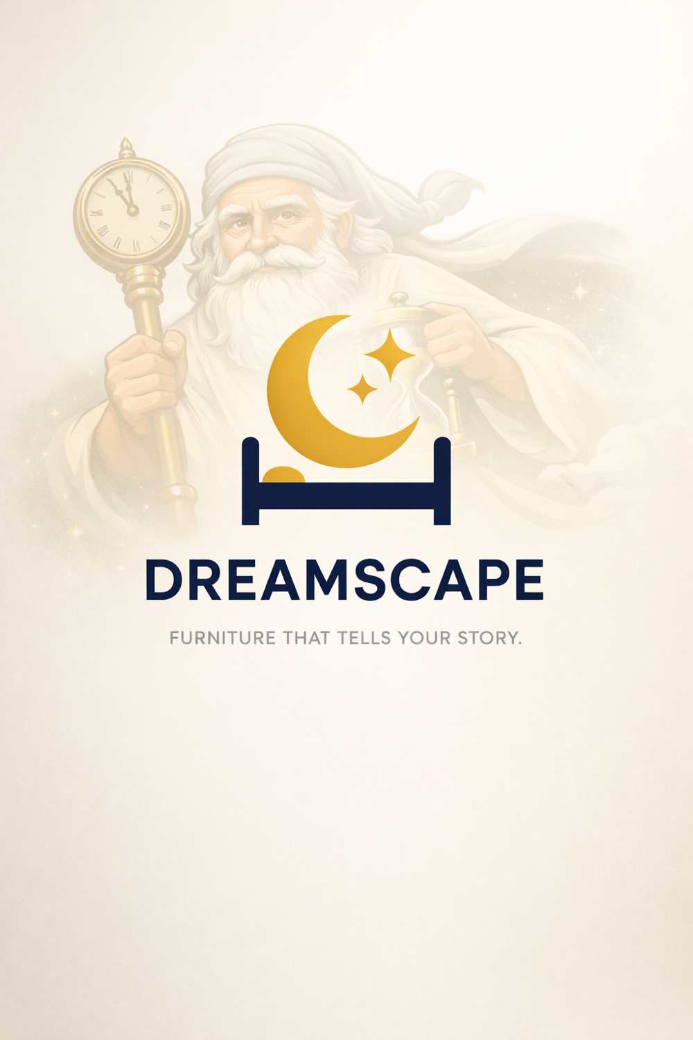
DREAMSCAPE™
Acquisition Packet
A Complete Business Sale Offering
"Escape Into a Dream" | "Furniture That Tells Your Story."
Presented By
Matthew Bonds
Innovator & Founder
May 2026
Strictly Private & Confidential | For Authorized Recipients Only
This document contains proprietary and trade-secret information. Unauthorized distribution is prohibited.

Section 01
Executive Summary

$1.1T+ Global Furniture Market by 2034 | 50–70% Target Gross Margins | 5–6% Global Market CAGR | $0 Direct Competitors in Niche

DREAMSCAPE™ is a first-of-its-kind, narrative-driven modular furniture brand positioned at the rare and powerful intersection of the global furniture market, premium home décor, bespoke custom design, and artificial intelligence technology. It is not a furniture store. It is not an interior design service. It is a new category — one that has never existed before — and it is being offered for acquisition as a complete, investor-ready business package.
The global furniture market stands at $666–$736 billion in 2024–2025 and is projected to reach $1.1–$1.16 trillion by 2034, expanding at a compound annual growth rate of 5–6%. Within that market, no company currently delivers what Dreamscape offers: themed, modular furniture environments built on a universal grid system, governed by an AI-assisted design portal, and driven by an order-based manufacturing model that eliminates inventory risk entirely.
This acquisition offering represents a ground-floor opportunity in a trillion-dollar industry. The buyer acquires not just a business concept, but a fully documented intellectual property estate: the Dreamscape™ brand, a filed patent application (#590601071) with ten technical figures, a comprehensive business plan, a modular design system, themed room environment library, Universe Bible, MicroRoom prototype specifications, and a complete AI portal architecture — everything needed to move from concept to commercial launch.
Year 1 revenue projections are structured across three execution scenarios. Under conservative conditions, the business targets $180,000–$300,000 in annual revenue. Strong execution is projected to deliver $350,000–$450,000, while a best-case scenario yields $550,000–$650,000. Target gross margins range from 50–70%, supported by order-based manufacturing, premium custom pricing, and high-margin design services.
The arithmetic of opportunity is compelling: capturing even 0.01% of a $1 trillion market represents over $100 million in potential revenue. Dreamscape is not competing for a slice of the existing pie — it is creating a new one. The hard work of vision, validation, IP documentation, and brand architecture is complete. What remains is the work of a capable, resourced operator ready to turn an extraordinary idea into a legendary brand.

"The hard part — the idea, the vision, the IP, the plan — is already done.
What remains is execution."
Matthew Bonds — Innovator & Founder, Dreamscape™

Section 02
Company Overview

Origin & Vision
Dreamscape™ was conceived by Matthew Bonds from something deeply personal: a lifelong habit of daydreaming. Like millions of working people around the world, Matthew spent years imagining escape — better places, better rooms, better lives. He noticed that this universal human desire — the fantasy of waking up somewhere extraordinary — had never been given a physical product to fulfill it. Interior design existed. Furniture brands existed. But no one had ever built a system that said: tell me your dream, and I will build it for you, piece by piece, module by module, theme by theme.
That insight became Dreamscape™.
Brand Mission: "We create personal portals for customers. They choose their room shape and size, then browse catalogues of diverse selections to create the dream they imagine."
Mission Statement: "Our product is dependable, comfortable, and creative. We care for our clients and nurture their innovation. We hold dear our stakeholders and where the two meet we mend trust and create a bond."
The Dreamscape concept centers on themed furniture environments — bedrooms, living rooms, dining rooms, outdoor spaces — all built around interchangeable modular components that allow any room to become a dream destination. Every piece is designed to be a building block. The product range spans bedroom sets (beds, dressers, wardrobes, nightstands, bookshelves), living room sets (coffee tables, ottomans, armoires, lamps), dining room and closet furniture, and outdoor and lawn furniture.
The brand targets a broad but intentional customer base: from working-class families dreaming of something beautiful, to affluent buyers seeking truly one-of-a-kind custom environments. Whether the customer dreams of travel, gaming, art, history, fantasy, nature, or simply self-expression — Dreamscape has a theme, a module, and a room waiting for them.
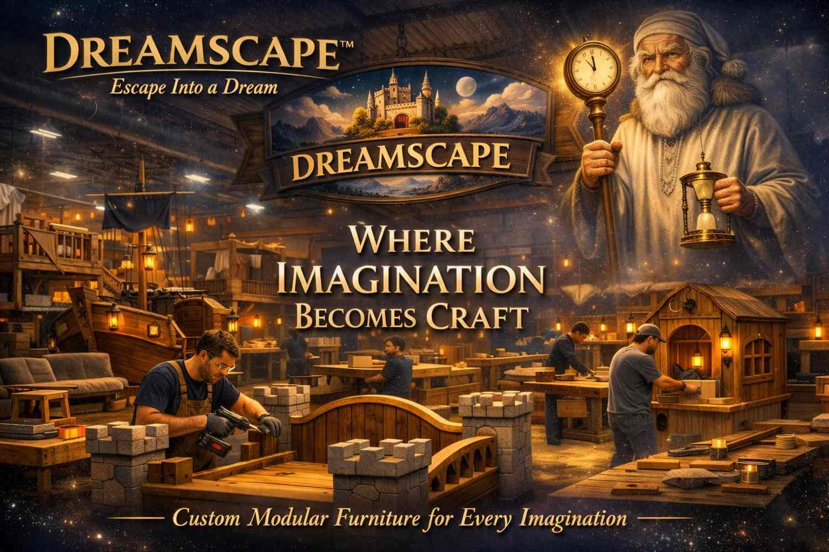
Dreamscape™ Workshop — Custom modular furniture components in production. Every piece is engineered to be part of a larger, interchangeable theme system.

Section 03
Product
&
IP Assets

3A — The Dreamscape Product Universe
Dreamscape furniture is engineered on a philosophy borrowed from the greatest modular system ever invented: the LEGO principle. Every bed, dresser, wardrobe, nightstand, and table is a building block — modular, interchangeable, upgradeable. Parts can be mixed, matched, replaced, upgraded, and rearranged without tearing a room apart and starting over. The customer's room evolves as they do.
This is not customization as an afterthought. It is the engineering core of the brand. The Universal Grid Floor System (FIG. 4) connects every piece via a standardized magnet and peg connector interface. The Theme Cartridge System (FIG. 7) allows the aesthetic identity of a room to be swapped entirely. The result is a furniture ecosystem that grows with the customer for a lifetime.
Signature Example Room — Desert Island Beach Bedroom: An LED-lit ocean-floor carpet anchors the space. A four-poster bed is positioned over the "ocean." One nightstand takes the form of a boulder; another becomes a tropical shrub. A coconut-tree wardrobe stands in the corner. The dresser fronts are coral and seashell panels, illuminated by soft aquatic light. The customer doesn't just sleep in a room — they wake up on a beach.
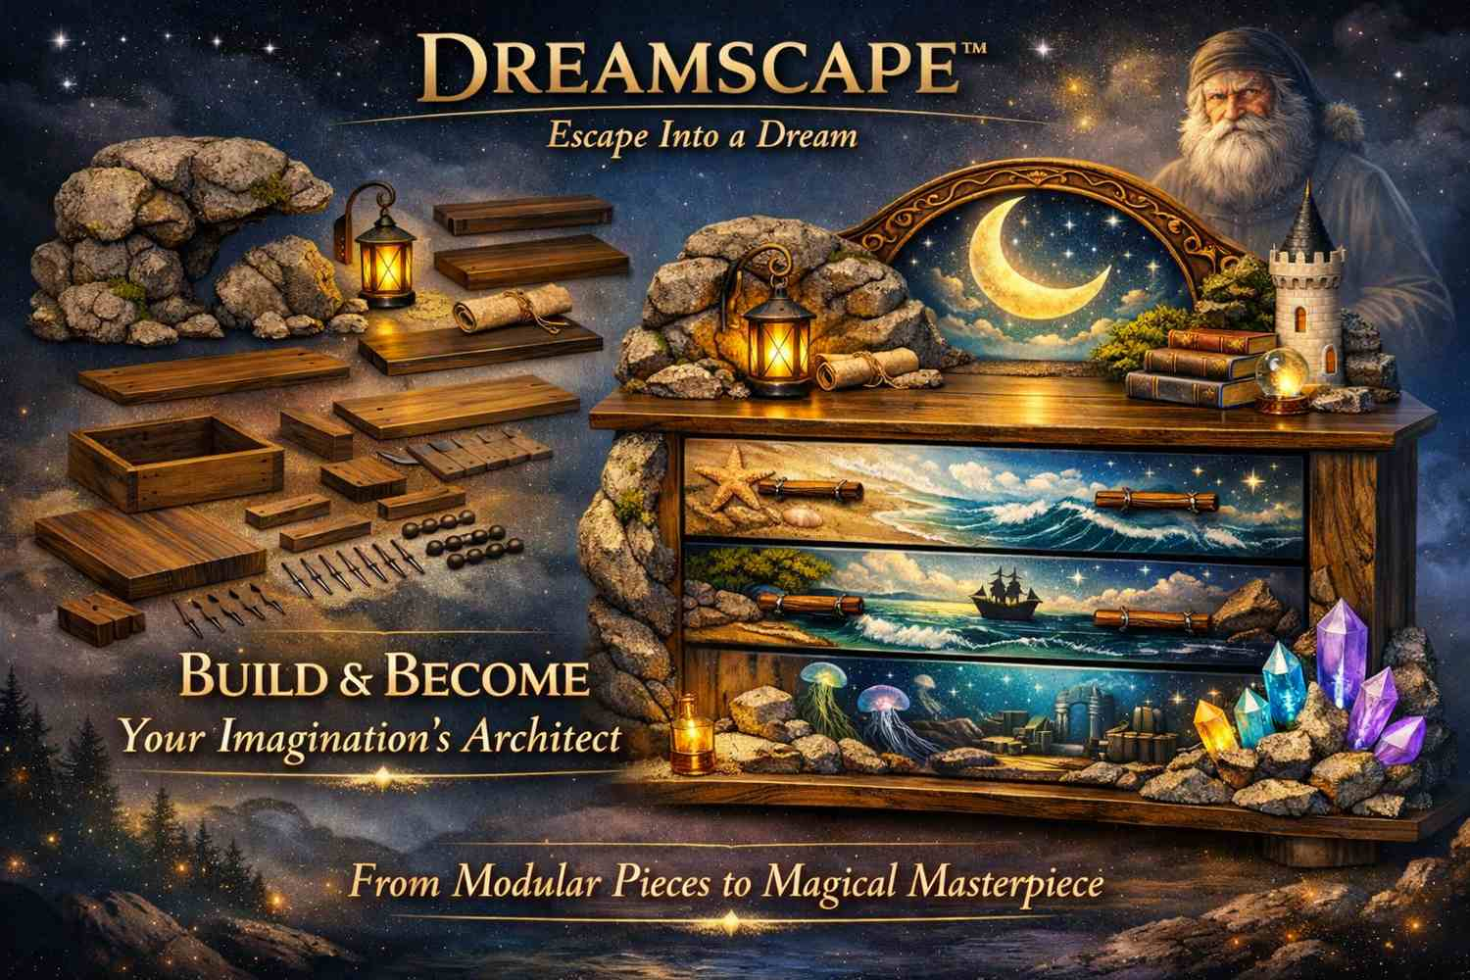
Dreamscape™ Signature Dresser — Ocean-themed interchangeable front panels (Coral, Seashell, and Water-Glass finishes). A demonstration of the modular panel system in production form.

3B — Themed Room Environments
The Dreamscape theme library is designed to be ever-expanding. Below is the founding collection of environments available at launch, each representing a distinct world customers can inhabit:

Theme | Design Signature
Desert Island / Beach | Sandy shores, ocean textures, aquatic lighting, driftwood tones, coral and seashell panels
Enchanted Forest | Natural wood tones, organic forms, moss and flora accents, earth-hued lighting
Cyber Temple | Futuristic glowing panels, LED structures, geometric shapes, metallic and glass surfaces
Rustic Cabin | Reclaimed textures, warm wood, lantern-style lighting, plaid and leather accents
Mythology / Olympus | Columns, god-like archetype panels, grand scale, marble and gold finishes
Fantasy Castle | Arched stonework, stained glass effects, dark wood, medieval ironwork
Cosmic / Asgard | Celestial themes, interstellar backdrop panels, deep indigo and silver tones
Historical / Cultural | Any era or civilization the client imagines — Roman, Egyptian, Feudal Japanese, Art Deco, and beyond

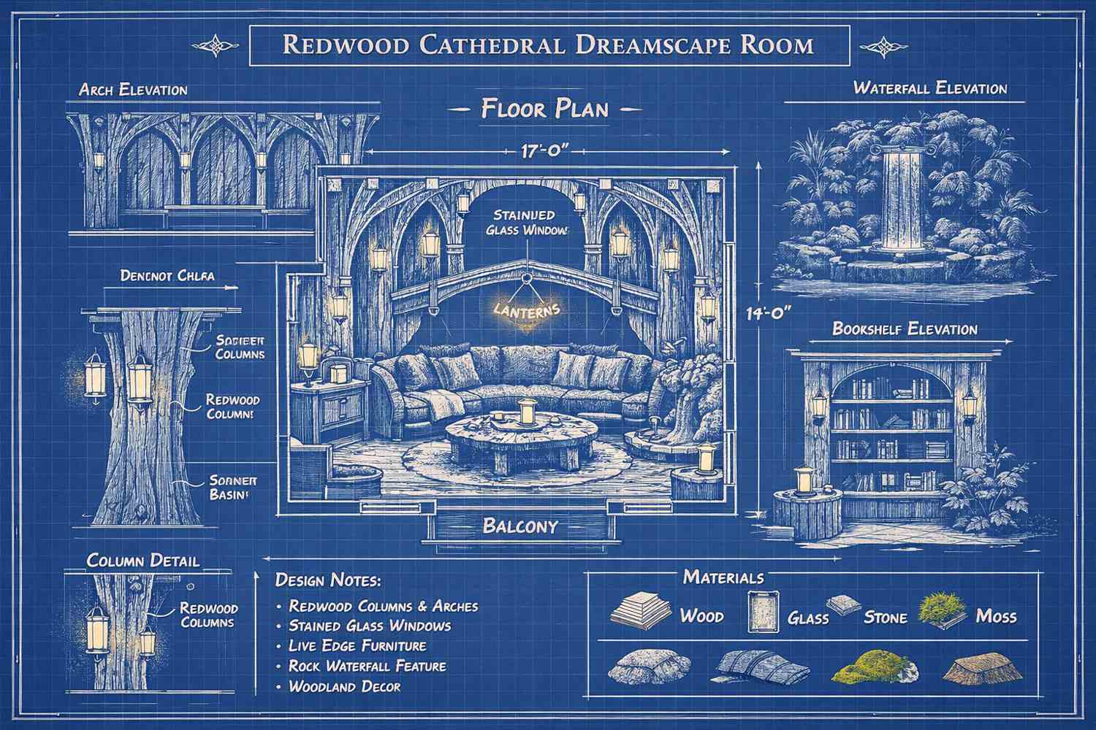
Dreamscape™ Architectural Blueprint — Redwood Cathedral Room Environment. Full-scale room design documentation, part of the IP package transferred to the buyer.

3C — Modular Engineering System & IP Assets

Patent Filing

Application #590601071 — "System Enabling Users To Design, Visualize, and Manufacture Furniture Environments Before Production"
Filed and documented with ten (10) technical invention figures covering the complete Dreamscape modular architecture.

The Dreamscape IP estate is comprehensive and technically documented. The following ten invention figures form the core of the patent application and represent the full scope of the protectable modular system:

Figure | Title & Description
FIG. 1 | System Architecture Block Diagram — Integrated Design & Manufacturing System connecting User Devices, Digital Room-Design Portal, Module Compatibility Rule Engine, Visualization Engine, Order-Based Manufacturing Trigger, and Templates / Component Library / Pricing Rules / User Accounts.
FIG. 2 | Process Flow — Full user journey: Portal Access → Room Template Selection → Component Selection → Compatibility Check → Conflict Resolution → Visual/Thematic Attributes → Full Room Visualization → Pricing Review → Design Approval → Deposit/Payment → Order-Based Manufacturing Trigger.
FIG. 3 | Graphical User Interface — Thematic Styling Menu (Fantasy, Historical, Travel); Room Template Selection (Bedroom, Office, Studio, Multi-Room); Dynamic Pricing & Cost Output with Pricing Guardrails. Sample estimate shown: $4,840.00.
FIG. 4 | Universal Grid Floor — 2-inch magnet/peg connector grid with 1-inch squares. Cross-theme compatible. The foundational connection standard for all Dreamscape furniture.
FIG. 5 | Modular Bed Frame Architecture — Four-post platform system with interchangeable post types: Tree, Crystal, Mushroom, Stone, and Cyber Obelisk. Integrated LED chamber below the platform for ambient lighting.
FIG. 6 | Interchangeable Sculptural Panel System — Four archetype panels mounting to a Universal Frame: Queen (Panel A), Mother (Panel B), Warrior (Panel C), Goddess (Panel D). Panels are swappable without disassembly.
FIG. 7 | Theme Cartridge System — Swappable tray system with Sand, Water, Stone, and Forest theme elements. Allows complete aesthetic identity of a piece to be changed by the customer.
FIG. 8 | MicroRoom Prototype Shell — Ceiling Panel, Thematic Printed Back Wall, Removable Side Walls, and Floor Grid. The tabletop demonstration model of the complete Dreamscape environment.
FIG. 9 | Wardrobe Core + SlideOn Skins — Universal wardrobe chassis with fully interchangeable outer skins (Tree Skin, Stone Skin, and other theme variants) applied without tools.
FIG. 10 | Dresser Core + Interchangeable Front Panels — Standard dresser chassis with swappable front panel faces including Coral, Wood, and Crystal options, fully compatible with the Universal Grid.

Key IP Claims Summary
• Universal modular chassis applicable across all furniture categories
• Interchangeable sculptural archetype panels (Queen, Mother, Warrior, Goddess)
• Theme cartridge swappable tray system for full aesthetic transformation
• Plug-and-play integrated LED lighting modules
• Universal Grid Floor System (cross-theme compatible)
• Scalable MicroRoom physical demonstration model
• AI-assisted digital design and order-trigger portal architecture

3D — MicroRoom Prototype Demonstrator
The MicroRoom is one of Dreamscape's most powerful commercial assets — a tabletop-scale, physical proof-of-concept model that brings the entire brand promise into a single, holdable object.

Specification | Detail
External Envelope | 18" × 14" × 12" (approximately microwave-sized)
Internal Usable Volume | 16.5" × 12.5" × 10.5"
Connection System | ¼" neodymium magnets or standard peg connectors
Theme Components | Swappable theme trays, miniature modular furniture sets
Lighting | Integrated LED lighting system
Viewing Panel | Clear acrylic "portal window" front panel
Primary Use Cases | Trade show demonstrations, retail display, investor presentations

The MicroRoom proves all three Dreamscape pillars simultaneously in a single compact object: a themed room environment, modular interchangeable furniture, and the "portal" experience of seeing your dream before you buy it. It has been described internally as "a physical UI for Dreamscape" — tangible, visual, and immediately compelling to any audience.

3E — AI-Assisted Digital Design Portal
The Dreamscape digital platform is the brand's commercial engine — a proprietary AI-assisted room design experience that transforms furniture shopping from a transaction into an event. Customers engage with the portal through an intuitive, gamified interface that guides them from blank room to fully designed dream environment before a single piece of furniture is manufactured.
Customer Journey Through the Portal:
- Select room type: studio apartment, 1-bedroom, 2-bedroom, office, multi-room home
- Browse and select from the themed environment library
- Customize with modular furniture components — mix, match, and swap freely
- Compatibility Rule Engine enforces design integrity — flags conflicts and suggests alternatives automatically
- Real-time dynamic pricing output with built-in guardrails prevents runaway estimates
- Visualization Engine generates a full-room preview before any commitment is made
- Approved design converts to an order-based manufacturing trigger upon deposit/payment

Design as a Game
The portal is engineered to feel like a game — engaging, exploratory, and shareable. Customers show off their room designs socially before they've made a purchase. This creates organic word-of-mouth marketing at zero marginal cost and converts browsers into buyers through emotional investment in their own design.

Section 04
Financial Highlights

Year 1 Revenue Scenarios

Scenario | Annual Revenue | Monthly Average | Avg. Order Value | Gross Margin
Conservative | $180,000 – $300,000 | $15,000 – $25,000 | $4,000 – $6,000 | 50 – 60%
Strong Execution | $350,000 – $450,000 | $29,000 – $37,500 | $6,000 – $7,500 | 60 – 65%
Best Case | $550,000 – $650,000 | $46,000 – $54,000 | $7,500 – $9,000 | 65 – 70%

Operating Expenses & Gross Profit
Estimated Year 1 Operating Expenses: $220,000 – $260,000, covering labor, marketing, software/AI platform, rent and workshop facilities, and administration/legal.

Revenue Baseline | Gross Margin | Gross Profit
$525,000 | 65% | $341,250
$525,000 | 70% | $367,500

Material Cost Benchmarks

Cost Component | Range
Dresser — Plywood component | $50 – $150
Dresser — Solid wood component | $50 – $150
Dresser — Hardware | $20 – $100
Dresser — Finishing | $20 – $50
Total Dresser Material Cost | $100 – $500
Professional Assembly | $120 – $300
Market Sale Price (2–3× material cost) | Significant margin captured

Cash Flow Strategy
- 30–50% deposits required before production begins on any order
- Order-based manufacturing — zero inventory risk; nothing is built without a confirmed deposit
- Break-even projected: Month 6–9 of Year 1

Long-Term Growth Projections
- Year 2–3: 15–25% annual revenue growth
- Year 4+: Potential to significantly outpace the global furniture market CAGR of 5–6%
- TAM Upside: 0.01% capture of a $1T market = $100M+ revenue potential

Revenue Expansion Levers

• Premium design consultation sessions: $250–$500/session (credited toward purchase) — projected $78,000/year at 5 sessions/week
• Furniture rental and subscription model — recurring monthly revenue stream independent of unit sales
• Customer financing and layaway programs — expand working and middle-class market access and order volume
• Internal Brokerage & Financial Services Department — annuities, capital management, and interest revenue
• Distribution and wholesale layer — licensing theme collections to retail partners
• Art exhibit and gallery-style showcase events — brand elevation and direct sales channel
• AOV uplift from theme bundles, LED packages, and white-glove installation services

Section 05
Market Opportunity

The Furniture Market at Scale
The global furniture industry is one of the most durable and consistently growing consumer markets on earth. The United States alone generates $125–$140 billion in annual furniture sales — including $140 billion in retail sales recorded in 2023. Globally, the market is valued between $666 and $736 billion for 2024–2025 and is on a clear trajectory toward $1.1–$1.16 trillion by 2034, driven by a compound annual growth rate of 5–6% — a remarkably strong figure for a mature consumer goods segment.
The structural dynamics favor Dreamscape's positioning. Residential furniture accounts for 60–66% of total industry revenue, with bedroom furniture representing the single largest product segment. Wood furniture — the primary material in Dreamscape's design system — accounts for 40–57% of global furniture sales, making Dreamscape's craft-forward approach precisely aligned with the dominant commercial medium.
What makes Dreamscape's opportunity exceptional is not simply that it enters a large market — it is that it enters at a rare intersection of four distinct high-value sectors: furniture (massive scale), home décor (high margin), custom design (premium pricing), and technology (AI visualization and gamification). No existing competitor operates across all four simultaneously.
The demand environment has never been more favorable. Key drivers include the ongoing home renovation boom, the normalization of remote-work lifestyles that elevate the importance of personal spaces, a cultural shift toward self-expression and aesthetic identity in the home, rising consumer interest in experiential furniture, the modular and multifunctional furniture trend, and the rapid expansion of AI-assisted visual shopping platforms.

Market Position — A Category of One
Dreamscape does not compete with IKEA or Ashley Furniture. It creates a premium niche category — Narrative Modular Furniture — where there are no established players, no commoditized pricing pressure, and no incumbent with a defensible position. The buyer enters a market of one and builds the rules from the ground up.

Even the most conservative market penetration math is transformative. At 0.01% of a $1 trillion market, Dreamscape represents $100 million or more in potential revenue — from a single-digit percentage slice of a single percentage point. The upside of a first-mover in a new category with defensible IP, a gamified purchasing experience, and zero existing competition is difficult to overstate.

Section 06
Operational Structure

Departmental Functions
Dreamscape is designed to operate efficiently from day one through a lean, scalable organizational structure. Six core functional areas govern the business:
- Design & Creative — Furniture concept development, theme engineering, and customization logic. This department owns the brand's visual identity and the ever-expanding theme library.
- Technology — AI room-design portal development and maintenance, website and gamified interface, software integrations, and compatibility rule engine.
- Manufacturing — Materials sourcing, furniture construction and finishing, quality control, and vendor/partner relationships.
- Sales & Customer Experience — Client onboarding, design consultations, order processing, and post-sale relationship management.
- Logistics & Installation — Shipping coordination, white-glove delivery, and on-site assembly services for premium orders.
- Administration — Accounting, human resources, legal compliance, and IP management.

Customer Workflow
Customer Designs Room in AI Portal → Design Approved & Priced → Order Sent to Manufacturing → Furniture Built & Finished → Delivered & Installed

Early-Stage Staffing (Lean Launch)
- Founder / CEO — Strategic direction, brand vision, and investor/client relationships
- 1 Designer — Theme development and custom design execution
- 1 Technology Contractor — Portal build-out and software maintenance
- Manufacturing Partner or Small In-House Team — Modular furniture production

Scalability Architecture
The business is engineered for growth without exponential cost increases. Standardized modular designs reduce production complexity. The expanding theme catalog adds revenue without adding operational overhead. Automated ordering through the AI portal reduces the sales team headcount required per order. As order volume grows, manufacturing can scale through partner networks or expanded in-house capacity with no disruption to the core design system.

Buyer's Implementation Timeline

Phase | Timeline
Research & Development | February – April
Copyright & Patents | May – July
Blueprints & Prototype | August – September
Commercial Launch | October – Completion

Section 07
Competitive Advantages

ADVANTAGE 01
First-Mover Position in a New Category. No company currently offers narrative-driven, sculptural, theme-cartridge modular furniture with a universal grid and AI visualization. Dreamscape does not enter an existing category — it defines a new one. The buyer becomes the category creator, with all the pricing power, brand equity, and market-shaping authority that position commands.

ADVANTAGE 02
Patent-Protected Modular Architecture. The IP includes ten documented invention figures covering the universal grid, modular chassis, interchangeable sculptural panels, theme cartridges, lighting modules, and the AI portal system architecture. This documentation creates a defensible competitive moat before commercial launch — protecting the business from the moment the first customer walks through the door.

ADVANTAGE 03
Premium Pricing Power with Low Material Costs. Signature custom Dreamscape environments justify price points of $6,000 to $100,000 and beyond, while material costs remain a fraction of the sale price. The combination of bespoke design, narrative branding, and AI-assisted customization supports gross margins of 50–70% — exceptional for the furniture category and consistent with premium luxury goods economics.

ADVANTAGE 04
AI-Assisted Design Portal Creates Viral Engagement. The gamified room-design tool converts browsers into buyers through emotional investment in their own design — before they've spent a dollar. Customers share their room designs socially, generating organic brand exposure at zero incremental cost. The portal turns the pre-purchase phase into a marketing engine.

ADVANTAGE 05
Order-Based Manufacturing Eliminates Inventory Risk. Nothing is manufactured until a deposit is received. This fundamentally inverts the risk profile of a traditional furniture business — eliminating the single largest cost risk (unsold inventory) and keeping cash flow positive from the earliest stages of operations. It is a structural advantage that no legacy competitor can easily replicate.

ADVANTAGE 06
Hybrid Revenue Model Across Multiple Streams. Dreamscape generates revenue from furniture sales, premium design consultations, customer financing programs, layaway plans, rental and subscription models, and a planned internal brokerage and financial services department. This diversification insulates the business from the cyclicality of any single revenue line and creates compounding income over time.

ADVANTAGE 07
Emotional and Cultural Resonance No Competitor Can Manufacture. Dreamscape taps into universal human desires: travel, fantasy, belonging, memory, and self-expression. The brand story — born from the daydreams of a working American who believed that everyone deserves to live inside their imagination — gives it a cultural authenticity that no corporate competitor can manufacture. Brands built on genuine human experience last. This one was built on exactly that.

Section 08
Valuation Rationale

What the Buyer Is Acquiring
This is not an acquisition of machinery, inventory, or a customer list. The buyer is acquiring a complete, investor-grade intellectual property and business development package — everything required to move from concept to commercial operation without starting from zero. The acquisition package includes:
- Dreamscape™ brand name and trademark-eligible brand identity and visual assets
- Full business plan — seven-section comprehensive operating document
- Patent application #590601071 — ten technical invention figures covering the complete modular system
- Universe Bible / brand guide — the definitive design and narrative governance document
- MicroRoom prototype design — specifications, dimensions, and engineering documentation
- AI portal architecture documents — complete system flow and technical specifications
- Theme library — eight founding environment collections with expansion roadmap
- Modular design system specifications — universal grid, chassis, panel, and cartridge standards
- Full seller authority to proceed — granted and signed by Matthew Bonds, Innovator and Founder

Valuation Framework
Custom modular furniture brands with proprietary IP systems command significant premiums over commodity furniture businesses. The Dreamscape valuation should not be anchored to physical assets — it should be anchored to the IP value, first-mover position, market opportunity, and the cost and time it would take any competitor to replicate this documentation, this design system, and this brand architecture from scratch.
Critically, the business carries no prior operational losses. It has not yet launched — meaning the buyer inherits an entirely clean financial slate with all groundwork complete. There are no legacy liabilities, no failed campaigns, no inventory write-downs, and no reputational baggage. The buyer starts at zero on the liability side and at a significant head start on the asset side.
With a total addressable market exceeding $1 trillion, IP protection across the core modular system, and no established competitor in the narrative-modular furniture niche, the appropriate valuation framework is one aligned with early-stage IP and brand acquisition premiums — not furniture-industry asset multiples.

"What if no such thing exists? What if there are no standard blueprints created or patents established and you were sitting here with the idea in your hands, and no one knew? What if everyone knew and they wanted some?"
Matthew Bonds — Dreamscape™ Business Plan

Section 09
Buyer Benefits
&
What's Included in the Sale

What You Receive — Complete Acquisition Package

Intellectual Property Assets ✓ Dreamscape™ brand name and identity ✓ Patent application #590601071 (10 technical figures) ✓ Universe Bible & brand design guide ✓ Complete business plan (7 sections) ✓ Modular furniture IP system specification ✓ Theme cartridge library documentation ✓ AI portal architecture & system flow | Business Foundation Assets ✓ Full market research and analysis ✓ Financial model and projections (3 scenarios) ✓ Operational structure blueprint ✓ Customer experience workflow ✓ MicroRoom prototype specifications ✓ Manufacturer sourcing roadmap ✓ Full seller authority to proceed (signed by Matthew Bonds)

A Note to the Buyer
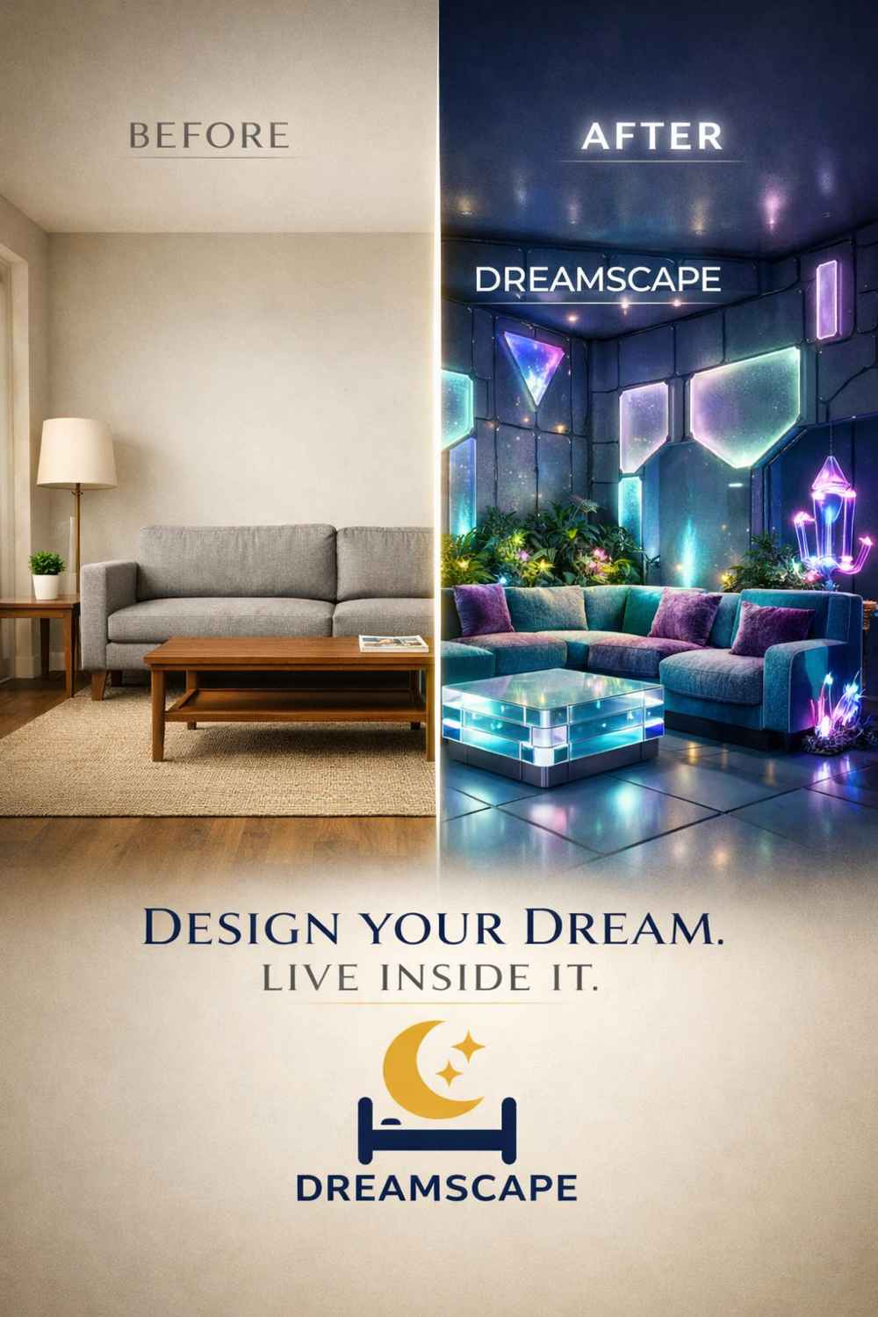
Dreamscape™ — Before & After. The transformation that awaits every customer. The transformation that awaits the right buyer.

Dreamscape is not just furniture. It is a portal.
People all over the world dream every night of places they have never been — beaches they have never felt, forests they have never walked through, rooms they have never slept in. They dream of the lives they are still building, the spaces that would finally feel like them. This brand gives them the door.
The buyer of Dreamscape™ does not merely acquire a business. They acquire the chance to help millions of people live inside their dreams — to wake up every morning in a room that says: this is who I am, and this is where I belong.
The hard work is done. The idea has been born, named, documented, and protected. The vision has been mapped, the IP filed, the system engineered, the market validated. What remains is execution — and that is where a capable, resourced, and visionary new owner can take something extraordinary and make it legendary. The world is ready for Dreamscape. The only question is whether you are ready for the world.

Section 10
Seller Authority
&
Closing Statement

Declaration of Ownership & Seller Authorization
The following statement constitutes the formal seller authority declaration, executed by the Innovator and Founder of Dreamscape™, granting full and complete authority to the acquiring party to proceed with all rights, assets, and operational authority transferred through this acquisition:

Official Seller Declaration
"I, Matthew Bonds, Innovator, Project Owner, and Seller, hereby claim all ownership of this idea and its processes of execution. I approve the buyer and give them full authority to proceed."

Matthew Bonds
Innovator & Founder, Dreamscape™
Date: February 2026

Acquisition Inquiries
All acquisition inquiries, due diligence requests, and formal expressions of interest should be directed to the seller's representative. This packet is presented in strict confidence to authorized recipients only. Unauthorized reproduction, distribution, or disclosure of this document or its contents is expressly prohibited.

Contact for Acquisition Inquiries

Matthew Bonds
Innovator & Founder — Dreamscape™
Direct acquisition inquiries only | Confidential correspondence welcomed
South Salt Lake, UT, United States

DREAMSCAPE™ — Acquisition Packet 2026 | Prepared by Matthew Bonds, Innovator & Founder | May 2026
This document is strictly private and confidential. All intellectual property, brand assets, and business concepts contained herein are the exclusive property of Matthew Bonds.
Patent Application #590601071 on file. Dreamscape™ is a trademark-eligible brand identity. Unauthorized use is prohibited.
"Escape Into a Dream" | "Furniture That Tells Your Story."

