This is…
A non-functional demonstration model designed to show modular, interchangeable themed furniture at microwave scale with magnets, removable parts, and lighting.

DREAMSCAPE MICRO-ROOM PROTOTYPE
Project Name: Dreamscape™ Micro-Room Demonstrator
Purpose: Physical proof-of-concept for themed, modular, interchangeable Dreamscape environments
Scale: Tabletop / microwave-sized
Function: Demonstration + sales visualization (not functional furniture)

1. OVERALL DIMENSIONS (MICROWAVE SCALE)
External Envelope (W × D × H):
18 in × 14 in × 12 in
(457 × 356 × 305 mm)
This size:
- Reads immediately as “microwave-sized”
- Fits on desks, pedestals, trade-show tables
- Is large enough to clearly show modular swaps
Internal Usable Room Volume:
16.5 × 12.5 × 10.5 in (419 × 318 × 267 mm)

2. CORE CONCEPT (WHAT THIS PROVES)
This model demonstrates three Dreamscape pillars at once:
- A themed room (immersive mini environment)
- Modular furniture (interchangeable parts)
- A “portal” view (see the dream before you buy)
Think of it as a physical UI for Dreamscape.

3. STRUCTURAL BLUEPRINT (THE ROOM SHELL)

A. Shell Components
Part | Qty | Size (in) | Notes
Base / Floor | 1 | 18 × 14 | Structural, holds grid + connectors
Back Wall | 1 | 18 × 12 | Fixed backdrop
Side Walls | 2 | 14 × 12 | Removable
Ceiling Panel | 1 | 18 × 14 | Optional (recommended for LEDs)
Front Panel | 1 | 18 × 12 | Clear acrylic “portal window”
Materials (recommended):
- Walls: 3–5 mm MDF or foam board
- Front: clear acrylic / plexiglass
- Finish: matte white or neutral gray (gallery look)

4. MODULAR GRID SYSTEM (THE KEY FEATURE)

Universal Dreamscape Grid
- Grid size: 1 in × 1 in squares
- Grid etched, drawn, or printed on floor
- Connector points every 2 inches
This grid is what makes everything interchangeable.

Connector Options (pick one)
Option A – Magnets (Best for demos)
- ¼ in neodymium magnets
- Embedded flush in floor + module bases
Option B – Peg System
- ⅛ in dowel pegs
- Peg holes drilled on grid intersections
This is the physical proof of “LEGO-like furniture” described in Dreamscape.

5. INTERCHANGEABLE ROOM “CARTRIDGE”

Theme Tray (Swappable Floor System)
- Tray size: 16.5 × 12.5 in
- Drops into the shell like a cartridge
- Entire room theme can be swapped in seconds

Example Theme Tray: “Desert Island”
- Left half: sand texture
- Right half: ocean texture
- Soft shoreline blend
- Optional under-floor blue light for water effect

6. MODULAR FURNITURE SYSTEM (MINIATURE SCALE)
All furniture snaps into the same grid.

A. Bed Platform Module (Core Demo Piece)
Footprint: 6 × 4 in
Height: 2 in
Features:
- Flat deck
- Transparent blue insert under deck
- LED glow underneath (“moving water” illusion)
Interchangeable Parts:
- 4 removable corner posts:
  - Plain
  - Palm tree
  - Stone column
  - Futuristic pillar
👉 This shows how one bed = many dreams.

B. Wardrobe Module
Footprint: 3.5 × 2 in
Height: 5 in
Interchangeable Skins:
- Coconut tree
- Stone tower
- Modern closet shell
Core body stays the same. Skins slide on/off.

C. Dresser Module
Footprint: 5.5 × 2 in
Height: 2.5 in
Interchangeable Front Panels:
- Coral & shells
- Carved wood
- Minimalist slab

D. Nightstands (Non-Standard by Design)
Footprint: 1.5 × 1.5 in
Height: 1.5 in
Examples:
- Boulder
- Shrub
- Pillar
- Floating cube
These intentionally break “normal furniture logic” to reinforce Dreamscape’s creativity.

7. TOP-DOWN BLUEPRINT (ASCII FLOOR PLAN)
18 in
┌────────────────────────────────┐
│ │
│ [ Wardrobe ] [ Wardrobe ] │
│ │
│ ┌──────────────┐ │
│ │ Bed Core │ │
│ └──────────────┘ │
│ [ Night ] [ Night ] │
│ │
│ ┌──────────────┐ │
│ │ Dresser │ │
│ └──────────────┘ │
│ │
└────────────────────────────────┘
14 in
Every block can be lifted, swapped, rotated, or replaced.

8. FRONT ELEVATION (PORTAL VIEW)
12 in
┌────────────────────────────────┐
│ LED strip (soft ambient glow) │
│ │
│ Backdrop (sky / horizon) │
│ │
│ Bed + glowing water effect │
│ │
│ Modular furniture silhouettes│
│ │
│ Clear acrylic "portal window" │
└────────────────────────────────┘

9. LIGHTING & POWER (SAFE + SIMPLE)
- Ceiling LED strip (warm or cool)
- 1–2 LEDs under bed
- Power:
  - USB power bank OR
  - 3×AA battery pack hidden behind wall
Lighting is not decorative only — it reinforces immersion.

10. WHAT THIS MODEL DEMONSTRATES (CLEARLY)
✅ Themed environments
✅ Modular furniture
✅ Interchangeable parts
✅ Premium “design-before-buy” concept
✅ Scalability from miniature → real rooms
This single object explains Dreamscape faster than words.

11. HOW THIS SCALES TO THE REAL PRODUCT
Micro Model | Full-Scale Reality
Grid floor | Standardized room templates
Swappable trays | Theme catalogs
Magnetic modules | Modular furniture systems
Portal window | AI visualization software
Mini lighting | Real LED integration

12. NEXT LOGICAL EVOLUTION
- Multiple theme trays in a carrying case
- QR code on model → AI portal demo
- Used as:
  - Investor piece
  - Trade-show centerpiece
  - Retail showroom object
  - Design consultation tool
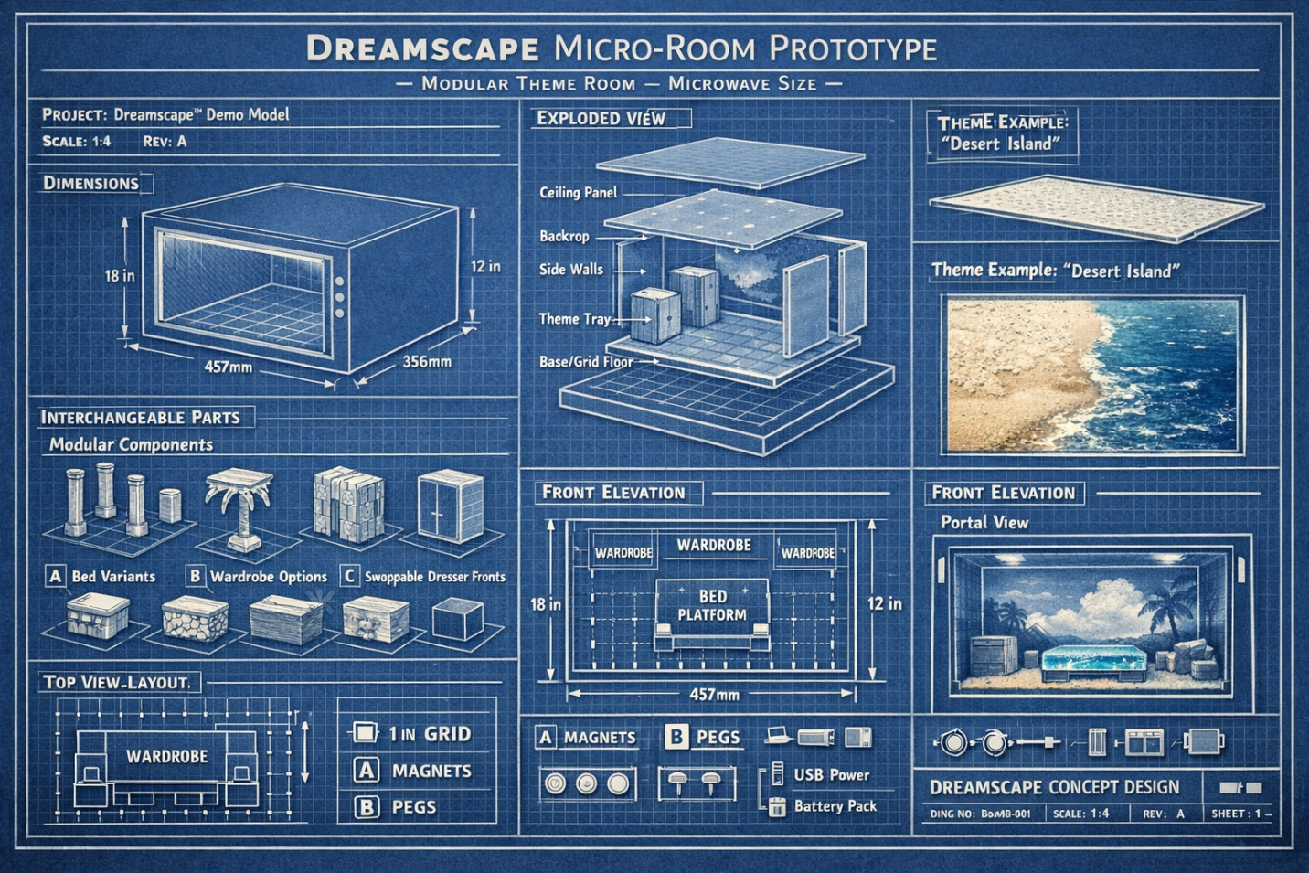
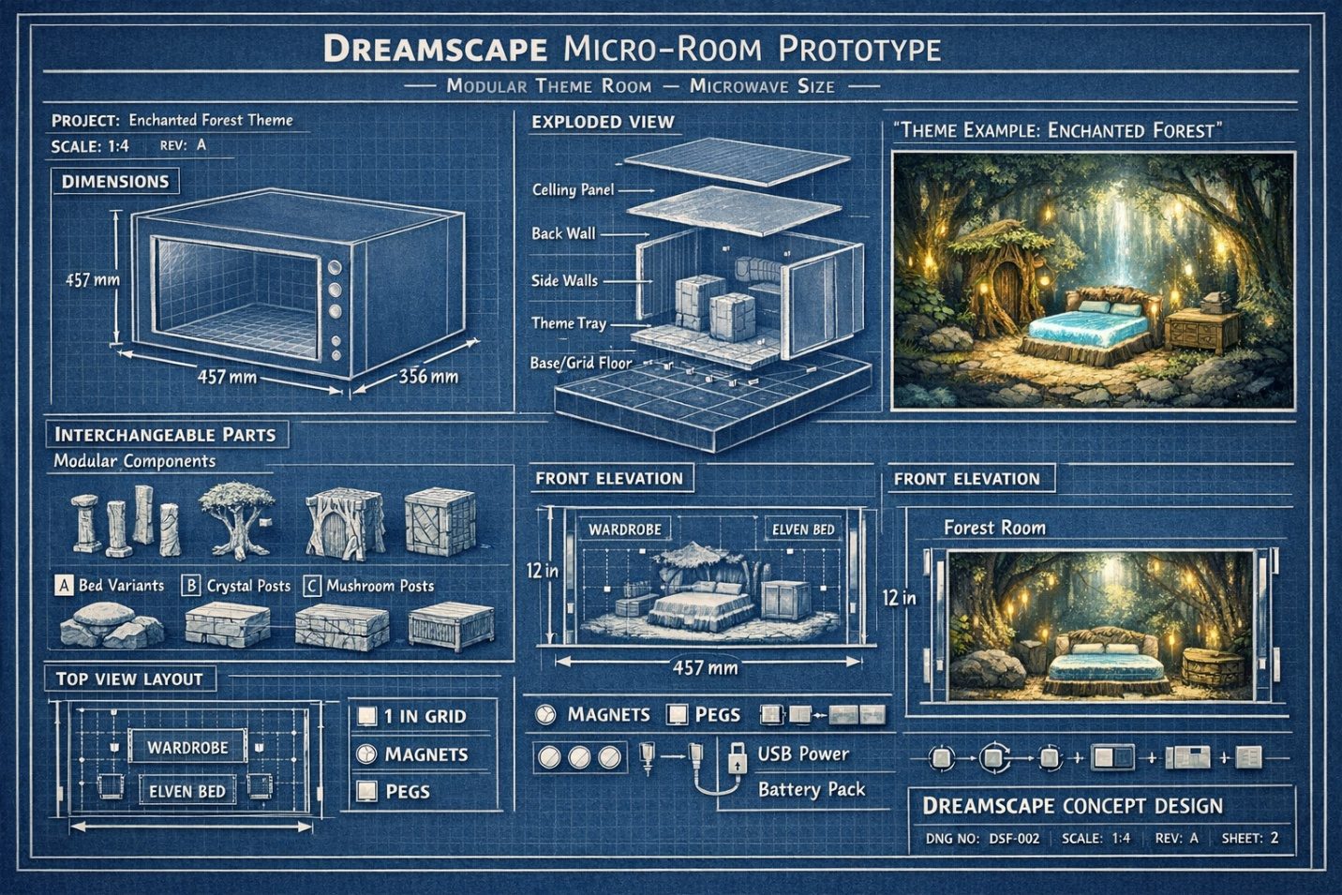

DREAMSCAPE™ MICRO-ROOM PROTOTYPE

Enchanted Fantasy Forest Theme
Demonstration Blueprint – Written Specification

1. PURPOSE OF THE PROTOTYPE
The Dreamscape Enchanted Fantasy Forest Micro-Room is a tabletop, microwave-sized demonstration model designed to physically communicate the Dreamscape concept:
- A themed environment presented as a miniature room
- Modular, interchangeable furniture components
- A “portal view” that allows viewers to look into a dream setting before purchase
This prototype is not functional furniture. It is a visual, tactile proof-of-concept intended for:
- Investor demonstrations
- Trade-show displays
- Retail showroom consultation tools
- Concept validation and design discussion

2. OVERALL SIZE & SCALE

External Dimensions (Microwave Scale)
- Width: 18 inches (457 mm)
- Depth: 14 inches (356 mm)
- Height: 12 inches (305 mm)
This scale:
- Clearly reads as “microwave-sized”
- Fits easily on desks, counters, or pedestals
- Is large enough to show detail, lighting, and modularity

Internal Room Volume
- Usable interior: 16.5 × 12.5 × 10.5 inches
(419 × 318 × 267 mm)

3. ROOM SHELL CONSTRUCTION
The room shell acts as a neutral gallery frame for the fantasy environment.

Structural Components
- Base / Floor Panel: Structural foundation containing the modular grid
- Back Wall: Fixed wall with enchanted forest backdrop
- Left & Right Side Walls: Removable for access and demonstration
- Ceiling Panel: Optional; supports ambient lighting
- Front Panel: Clear acrylic “portal window”

Materials
- Walls: MDF or foam board (3–5 mm thick)
- Front: Clear acrylic or plexiglass
- Finish: Matte neutral color (white, gray, or soft stone tone)
The shell is intentionally minimalist so the theme elements stand out.

4. MODULAR GRID SYSTEM (CORE FEATURE)
The floor of the room contains a universal Dreamscape grid, which enables all furniture to be moved, swapped, or replaced.

Grid Specifications
- Grid size: 1 inch × 1 inch squares
- Connector points: Every 2 inches
- Grid may be etched, printed, or lightly engraved

Connector Systems (Choose One)
Magnetic System (Recommended for demos):
- Small neodymium magnets embedded in floor and module bases
- Allows fast, tool-free swapping
Peg System (Mechanical alternative):
- Small dowel pegs and matching holes
- Provides physical alignment and stability
This system demonstrates how Dreamscape furniture scales from miniature to full-size modular systems.

5. SWAPPABLE THEME TRAY (ENVIRONMENT MODULE)

Enchanted Forest Theme Tray
- Tray size: 16.5 × 12.5 inches
- Drops into the room shell as a single unit
- Entire environment can be swapped without moving walls or furniture

Forest Ground Design
- Textured forest floor (stone path, moss, roots)
- Slight elevation changes to suggest terrain
- Optional embedded soft green lighting beneath translucent sections to simulate magical glow
The theme tray represents Dreamscape’s interchangeable room environments.

6. MODULAR FURNITURE COMPONENTS
All furniture pieces attach to the grid and are individually removable.

A. Enchanted Bed Platform (Core Feature)
- Footprint: 6 × 4 inches
- Height: 2 inches
Design:
- Wooden or stone-styled base
- Soft, glowing “magical energy” beneath bed (blue/green LED)
- Central visual anchor of the room
Interchangeable Bed Posts (Key Demo Feature):
- Tree-trunk posts
- Crystal spire posts
- Mushroom-cap posts
- Plain fantasy stone posts
Posts slot into the same base, showing how one bed transforms into multiple dream styles.

B. Wardrobe Module (Tree Hollow)
- Footprint: 3.5 × 2 inches
- Height: 5 inches
Core body: Neutral rectangular structure
Interchangeable skins:
- Hollow oak tree
- Ancient bark-covered trunk
- Elven carved wood shell
Skins slide on/off while the core remains unchanged.

C. Dresser / Storage Module
- Footprint: 5.5 × 2 inches
- Height: 2.5 inches
Swappable front panels:
- Moss-covered stone
- Rune-etched wood
- Crystal-inlaid fantasy slab

D. Nightstands (Non-Traditional Forms)
- Footprint: 1.5 × 1.5 inches
- Height: 1.5 inches
Examples:
- Mossy boulder
- Glowing mushroom
- Root-wrapped stone block
These intentionally avoid “normal furniture shapes” to reinforce the fantasy dream logic.

7. ROOM LAYOUT (TOP-DOWN DESCRIPTION)
- Bed platform centered against back wall
- Wardrobe placed to one side
- Dresser opposite or near foot of bed
- Nightstands positioned symmetrically or asymmetrically
All components can be:
- Lifted
- Rotated
- Replaced
- Removed entirely
This flexibility is the physical demonstration of Dreamscape’s modular promise.

8. PORTAL VIEW (FRONT EXPERIENCE)
The front acrylic panel acts as a window into the dream.
From the front, viewers see:
- Glowing enchanted bed
- Forest backdrop with soft light
- Magical highlights from crystals, mushrooms, or roots
- Furniture silhouettes arranged like a story scene
This mirrors how a customer would preview a full-scale Dreamscape room digitally.

9. LIGHTING & POWER

Lighting Elements
- Soft LED strip along ceiling or upper back wall
- Under-bed glow for magical effect
- Optional accent lights near crystals or mushrooms

Power Options
- USB power bank (hidden behind wall)
- Small AA battery pack
Lighting is subtle, immersive, and safe for tabletop display.

DREAMSCAPE™

Enchanted Fantasy Forest Micro-Room

Prototype Parts List (BOM)

1. ROOM SHELL & STRUCTURE (DISPLAY ENCLOSURE)

A. Structural Panels
Item | Qty | Dimensions | Material | Notes
Base / Floor Panel | 1 | 18 × 14 in | MDF or foam board (5 mm) | Structural foundation, holds grid
Back Wall Panel | 1 | 18 × 12 in | MDF / foam board | Fixed backdrop
Side Wall Panels | 2 | 14 × 12 in | MDF / foam board | Removable
Ceiling Panel | 1 | 18 × 14 in | MDF / foam board | Optional, supports lighting
Front Portal Panel | 1 | 18 × 12 in | Clear acrylic | Viewing window

B. Fastening & Assembly
- Wood glue or hot glue
- Small screws (optional, for removable panels)
- Magnetic catches or friction tabs (for side wall removal)

2. MODULAR FLOOR GRID SYSTEM (CORE MECHANISM)

A. Grid Surface
Item | Qty | Specification
Grid Overlay | 1 | 1 in × 1 in grid, etched or printed
Grid Area | 1 | Covers full interior floor

B. Connector System (Choose One or Both)
Option A – Magnetic System (Recommended for demos)
- Neodymium disc magnets, ¼ in diameter × 2–3 mm thick
  - Floor magnets: 12–20 pcs
  - Furniture base magnets: 2–4 per module
Option B – Peg System
- Wooden dowel pegs, ⅛ in diameter
- Matching drilled holes in floor grid and module bases
This system enables fast swapping and visibly demonstrates Dreamscape’s modular logic.

3. SWAPPABLE THEME TRAY (ENVIRONMENT MODULE)

Enchanted Forest Theme Tray
Item | Qty | Dimensions | Notes
Theme Tray Base | 1 | 16.5 × 12.5 in | Drops into shell
Terrain Layer | 1 | Same | Sculpted foam or textured paste
Forest Texture | — | — | Moss, roots, stone path
Translucent Inserts | Optional | — | For magical glow lighting

Decorative Materials
- Sculpting foam or clay
- Acrylic paints (earth tones, greens, browns)
- Artificial moss
- Small faux roots, bark texture pieces

4. MODULAR FURNITURE COMPONENTS

A. Enchanted Bed Platform (Core Demo Piece)
Item | Qty | Dimensions | Notes
Bed Base | 1 | 6 × 4 × 2 in | Attaches to grid
Translucent Insert | 1 | Fit to base | Blue/green “magic energy”
Under-bed LED | 1–2 | Micro LED | Soft glow effect
Post Sockets | 4 | Standardized | Accept interchangeable posts

Interchangeable Bed Posts
- Tree-trunk posts (4)
- Crystal spire posts (4)
- Mushroom-cap posts (4)
- Plain fantasy stone posts (4)
One bed + multiple post sets = clear modular transformation.

B. Wardrobe Module (Tree Hollow Style)
Item | Qty | Dimensions | Notes
Core Wardrobe Body | 1 | 3.5 × 2 × 5 in | Neutral structural core
Interchangeable Skins | 3 | Slide-on | Tree hollow, bark, elven carved

C. Dresser / Storage Module
Item | Qty | Dimensions | Notes
Dresser Core | 1 | 5.5 × 2 × 2.5 in | Fixed body
Swappable Front Panels | 3 | Clip-on | Moss stone, rune wood, crystal

D. Nightstand Modules (Non-Traditional)
Variant | Qty | Dimensions
Mossy Boulder | 1 | 1.5 × 1.5 × 1.5 in
Glowing Mushroom | 1 | 1.5 × 1.5 × 1.5 in
Root-Wrapped Block | Optional | Same

5. LIGHTING & ELECTRICAL COMPONENTS

Lighting
- LED strip (warm white or soft green) – 1
- Micro LEDs (blue/green) – 2–4
- Light diffuser (tracing paper or frosted plastic)

Power
- USB power bank or
- AA battery pack (3×AA)
- On/off toggle switch
- Thin insulated wiring
All lighting is low-voltage and display-safe.

6. DECORATIVE & SCENIC ELEMENTS
- Forest backdrop print (enchanted forest artwork)
- Mini crystals or resin gems
- Faux vines or leaves
- Painted stone props
- Mushrooms (foam or resin)
These elements are non-structural and theme-specific.

7. OPTIONAL DEMONSTRATION EXTRAS
- Carrying case for theme trays
- Labeled parts cards (“Interchangeable Posts,” “Swappable Skins”)
- QR code plaque linking to AI Dreamscape portal
- Small instruction card showing swap steps

DREAMSCAPE™

User Instructions – Interchangeable Parts

Welcome to Dreamscape
This model demonstrates how Dreamscape rooms and furniture are modular, interchangeable, and customizable.
Every major element you see can be removed, swapped, or replaced to create a new dream environment.
You are encouraged to touch, lift, and rearrange the components.

1. Understanding the Modular System

The Floor Grid
- The floor uses a standard grid system
- All furniture modules align to this grid
- Connection points are hidden beneath the floor surface
This grid is what allows parts to fit only where they belong, making swapping easy and intuitive.

2. Removing a Furniture Module
To remove any furniture piece (bed, wardrobe, dresser, nightstand):
- Place your fingers on both sides of the module
- Lift straight up
- The module will release from the floor connection
No tools or force are required.
If the piece resists slightly, lift gently and evenly.

3. Repositioning a Furniture Module
- Choose a new location on the grid
- Align the base of the module with the grid squares
- Lower the module straight down
- The module will snap into place automatically
This demonstrates how Dreamscape furniture can be rearranged without rebuilding a room.

4. Swapping Bed Posts (Key Feature)
The bed platform is designed to show how one core piece can transform into many styles.

To remove bed posts:
- Hold the bed steady with one hand
- Pull a post straight up from its socket

To install a different post style:
- Select a new post design (tree, crystal, mushroom, stone)
- Align the base of the post with the socket
- Press gently downward until seated
Repeat for all four corners to complete the transformation.

5. Changing Wardrobe Skins
The wardrobe consists of a core body and removable outer skins.

To remove a skin:
- Hold the wardrobe core with one hand
- Slide the outer shell upward or forward (depending on design)

To install a different skin:
- Choose a new wardrobe skin
- Slide it over the core body
- Press until it sits flush
This demonstrates how Dreamscape furniture can change appearance without replacing the entire piece.

6. Swapping Dresser Front Panels
The dresser allows its front face to be changed independently.
- Gently pull the front panel away from the dresser body
- Select a different panel design
- Align the panel edges
- Press until it clicks or sits flush
This shows how visual themes can be updated over time.

7. Changing the Theme Environment (Advanced Demo)
The entire room environment can be swapped using a theme tray.

To remove the theme tray:
- Remove all furniture modules first
- Lift the tray evenly from both sides

To install a different theme:
- Lower the new tray into the room shell
- Ensure it sits flat
- Reinstall furniture modules in any layout you choose
This represents how Dreamscape rooms can be redesigned without structural renovation.

8. Lighting Interaction
- Some modules include soft internal lighting
- Lights are for visual effect only
- Power is controlled by a small switch or external battery pack
Lighting enhances immersion but is not required for interaction.

9. What This Model Demonstrates
By interacting with this prototype, you are experiencing:
- Modular furniture design
- Interchangeable components
- Theme-based environments
- Design flexibility without demolition
- A physical preview of a dream space
This same system scales from miniature models to full-size rooms.

10. Care & Handling
- Lift pieces gently
- Do not force connections
- Return parts to their labeled positions after use
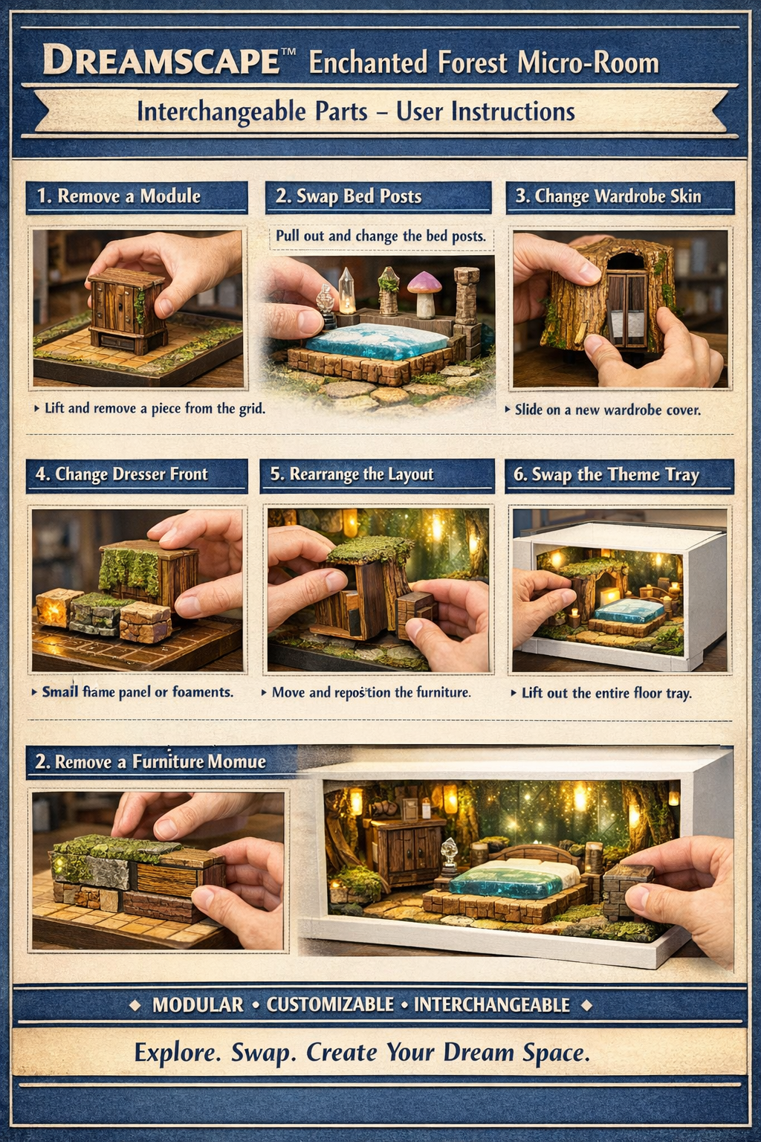
Below is a complete 3D print blueprint package you can hand directly to a CAD modeler or use yourself in Fusion 360 / SolidWorks / Blender.

🎛 DREAMSCAPE™ MICRO ROOM

3D PRINT MODEL BLUEPRINT (TABLETOP / MICROWAVE SCALE)
Print intent:
- Non-functional demonstration model
- Modular, swappable, magnet-ready
- Optimized for FDM printers (PLA / PETG)
- Split into discrete STL parts for easy printing and replacement

1. OVERALL PRINT STRATEGY
Do NOT print as one piece.
The system works best as modular STLs, mirroring the product concept.
✅ Easy transport
✅ Broken piece replacement
✅ Supports future themes
✅ Demonstrates modularity physically

2. MASTER ASSEMBLY DIMENSIONS (REFERENCE)
Dimension | Size
External shell | 457 × 356 × 305 mm (18 × 14 × 12 in)
Internal usable space | 419 × 318 × 267 mm
Grid pitch | 25.4 mm (1 in)
Connector spacing | 50.8 mm (2 in)
Wall thickness (printed): 4 mm
Structural tolerances: ±0.3 mm

3. PRINTED PARTS BREAKDOWN (STL LIST)

A. ROOM SHELL (STRUCTURAL)

1️⃣ Base / Floor (CORE PART)
STL: DS_Floor_Base_v1.stl
- Size: 457 × 356 × 6 mm
- Bottom: flat
- Top features:
  - 1″ engraved grid (0.5 mm depth)
  - Magnet sockets every 2″
Magnet sockets
- Diameter: 6.5 mm
- Depth: 2.6 mm
- Press-fit tolerance: +0.2 mm
✅ Print flat
✅ 20–30% infill
✅ No supports

2️⃣ Back Wall
STL: DS_BackWall_v1.stl
- Size: 457 × 305 × 4 mm
- Interior side:
  - Shallow recess (1 mm) for printed backdrop insert
✅ Print flat on back
✅ No supports

3️⃣ Side Walls (Left & Right)
STL: DS_SideWall_Left_v1.stl
STL: DS_SideWall_Right_v1.stl
- Size: 356 × 305 × 4 mm
- Bottom tabs:
  - Slide into floor slots
  - Allow removal for demos
✅ Mirror geometry
✅ No supports

4️⃣ Ceiling Panel (OPTIONAL)
STL: DS_Ceiling_Panel_v1.stl
- Size: 457 × 356 × 4 mm
- Internal LED channel:
  - 10 mm wide × 3 mm deep perimeter groove
✅ Print face-up
✅ Optional diffuser insert

5️⃣ Front Portal Frame
STL: DS_Portal_Frame_v1.stl
- Acrylic NOT printed (use 3 mm acrylic)
- Frame:
  - 6 mm thick bezel
  - Press-fit groove for acrylic

B. SWAPPABLE THEME TRAY
STL: DS_ThemeTray_Base_v1.stl
- Size: 419 × 318 × 6 mm
- Underside lip:
  - Prevents shifting inside shell
- Top surface:
  - Flat OR terrain-ready
✅ This is your core environment cartridge

4. MODULAR GRID + CONNECTORS

Magnet System (RECOMMENDED)
- Magnet type: Neodymium N52
- Size: 6 mm × 2 mm
- Floor polarity: all same orientation
- Furniture polarity: inverse
⚠️ Mark polarity before installation
⚠️ Glue after press-fit (CA or epoxy)

5. MODULAR FURNITURE — PRINT BLUEPRINTS

A. BED PLATFORM (CORE DEMO PIECE)
STL: DS_Bed_Base_v1.stl
- Size: 152 × 102 × 50 mm (6 × 4 × 2 in)
- Underside:
  - 4 magnet sockets
- Top:
  - 4 post sockets
  - Socket ID: 8.2 mm
  - Depth: 10 mm

Interchangeable Posts (Separate STLs)
DS_Post_Plain.stl
DS_Post_Tree.stl
DS_Post_Crystal.stl
DS_Post_Mushroom.stl
- Post base: Ø8 mm peg
- Height: 50–70 mm depending style
✅ No supports (design with 45° transitions)

B. WARDROBE — CORE + SKINS

Core
STL: DS_Wardrobe_Core_v1.stl
- Size: 89 × 51 × 127 mm
- Smooth uniform body
- Underside magnets

Skins (Slide-on)
DS_Wardrobe_Skin_Tree.stl
DS_Wardrobe_Skin_Stone.stl
DS_Wardrobe_Skin_Modern.stl
- Clearance: +0.6 mm
- Thickness: 3 mm
✅ Print skins vertically for surface detail

C. DRESSER
STL: DS_Dresser_Core_v1.stl
- Size: 140 × 51 × 64 mm

Front Panels
DS_Dresser_Front_Coral.stl
DS_Dresser_Front_Wood.stl
DS_Dresser_Front_Slab.stl
- Snap tabs: flexible PLA or PETG
- Tolerance: +0.4 mm

D. NIGHTSTANDS (INTENTIONAL VARIANTS)
Each is freestanding, grid-aligned:
DS_Night_Boulder.stl
DS_Night_Pillar.stl
DS_Night_Shrub.stl
DS_Night_Cube.stl
Size envelope:
- 38 × 38 × 38 mm

6. PRINT SETTINGS (RECOMMENDED)
Setting | Value
Layer Height | 0.2 mm
Nozzle | 0.4 mm
Infill | 20% gyroid
Walls | 3
Top / Bottom | 4 layers
Material | PLA (demo), PETG (durability)
Supports | NONE (by design)

7. POST-PRINT ASSEMBLY ORDER
- Install magnets in floor
- Install magnets in furniture bases
- Assemble shell (floor → back → sides)
- Drop in theme tray
- Place furniture modules
- Add LED + diffuser (optional)
- Insert acrylic portal window

8. FILE NAMING CONVENTION (IMPORTANT)
DS_[Category]_[Part]_[Version].stl
Example: DS_Furniture_Bed_Base_v1.stl
✅ Makes iteration clean
✅ Essential for investor demos

🎛 DREAMSCAPE™ MICRO

MODULAR FURNITURE THEME ②

LUNAR CYBER TEMPLE

Interchangeable Demonstration Furniture Set (3D Print Blueprint)
Theme purpose:
Demonstrate extreme stylistic transformation using the same underlying furniture cores, proving that Dreamscape is additive, modular, and future-proof, not theme-locked.

1. THEME CONCEPT
Lunar Cyber Temple blends:
- Futuristic architectural forms
- Lunar stone / sci-fi materials
- Glowing energy elements
- Sacred-tech hybrid aesthetics
This theme is intentionally the opposite emotional register of Enchanted Forest to maximize demo impact.
✅ Shows contrast
✅ Proves interchangeability
✅ Adds / removes in seconds
✅ Uses identical grid + magnets

2. COMPATIBILITY RULES (CRITICAL)
These parts are 100% compatible with:
- Existing Dreamscape grid (1 in / 25.4 mm)
- Existing magnet placement (6 × 2 mm)
- Existing furniture footprints
- Existing shell + theme tray
⚠️ No changes to floor, shell, or cores required

3. MODULAR FURNITURE COMPONENT BLUEPRINTS

A. BED PLATFORM — Lunar Temple Variant

Core (UNCHANGED)
DS_Bed_Base_v1.stl ← reuse existing

Interchangeable Posts — Lunar Set (NEW)
DS_Post_Lunar_Pylon.stl
DS_Post_Holo_Obelisk.stl
DS_Post_Temple_Column.stl
DS_Post_Energy_Totem.stl
Post Specifications
- Base peg: Ø8 mm
- Engagement depth: 10 mm
- Height: 55–70 mm
- Underside chamfer: 1 mm for easy insertion
Visual Features (Print-Friendly)
- Hard edges (≥45°) — no supports
- Recessed rune lines (0.6 mm depth)
- Optional LED light-pipe channel (2 mm dia)
✅ Swap live in demo
✅ One bed, radically different identity

B. NIGHTSTANDS — Floating Tech Relics
DS_Night_Holo_Dais.stl
DS_Night_Lunar_Cube.stl
DS_Night_Data_Obelisk.stl
Envelope
- 38 × 38 × 38 mm
- Underside magnet receiver
- Flat bottom for grid placement
Demonstration Note These deliberately ignore “normal” furniture logic to reinforce dream-logic environments.

C. WARDROBE — Cyber Shrine System

Core (UNCHANGED)
DS_Wardrobe_Core_v1.stl ← reuse

Slide-On Skins — Lunar Set (NEW)
DS_Wardrobe_Skin_TempleWall.stl
DS_Wardrobe_Skin_PanelizedTech.stl
DS_Wardrobe_Skin_HoloVeil.stl
Skin Specs
- Wall thickness: 3 mm
- Clearance: +0.6 mm
- Vertical print orientation recommended
- Internal alignment ribs (1.5 mm)
✅ Remove forest skin → add cyber temple skin
✅ No tools
✅ Same body, new dream

D. DRESSER — Modular Tech Altar

Core (UNCHANGED)
DS_Dresser_Core_v1.stl

Front Panels — Lunar Set (NEW)
DS_Dresser_Front_LunarStone.stl
DS_Dresser_Front_CircuitGlyph.stl
DS_Dresser_Front_EnergyGlass.stl
Panel Specs
- Snap-tab compatible with existing core
- Tab flex zone: 0.8 mm
- Tolerance: +0.4 mm
Demonstration Move Pop forest panel → snap cyber panel
(Time: ~3 seconds)

4. OPTIONAL THEME-SPECIFIC ACCENTS (NON-STRUCTURAL)
DS_Accent_Rune_Plate.stl
DS_Accent_Floating_Glyph.stl
DS_Accent_Energy_Node.stl
- Magnet-mount or free-place
- Used to “dress” a scene during demos
- Fully removable

5. PRINT SETTINGS (MATCH MAIN SYSTEM)
Suggested:
- Layer height: 0.2 mm
- Nozzle: 0.4 mm
- Material: PLA (demo) / PETG (durability)
- Supports: NONE
- Infill: 15–20% gyroid
- Walls: 3

6. DEMONSTRATION FLOW (INTENTIONAL DESIGN)
Live demo sequence
- Show Enchanted Forest bedroom
- Remove:
  - Bed posts
  - Wardrobe skin
  - Dresser front
  - Nightstands
- Install Lunar Cyber Temple components
- Turn on existing LEDs
👉 Same room
👉 Same furniture cores
👉 Entirely different dream

